# Copyright

# Copyright

# Copyright

# Copyright

DynaLift® 2013

© 2013 Weatherford International, Ltd. All rights reserved.

This document contains information proprietary to Weatherford International, with all rights reserved worldwide. Any reproduction or disclosure of this publication, or any part hereof, to persons other than Weatherford International personnel is strictly prohibited, except by written permission of Weatherford International.

Information in this document is subject to change without notice and does not constitute a commitment on the part of Weatherford International. It is supplied on an “as is” basis without any warranty of any kind, either explicit or implied. Information may be changed or updated in this document at any time.

The screen shots depicted in this document are for illustration purposes only. Several product features shown on the screen shots and described in the guide are specific to the integration options selected while configuring the DynaLift system, and may not be available on your installation.

# Copyright

DynaLift® 2013

© 2013 Weatherford International, Ltd. All rights reserved.

This document contains information proprietary to Weatherford International, with all rights reserved worldwide. Any reproduction or disclosure of this publication, or any part hereof, to persons other than Weatherford International personnel is strictly prohibited, except by written permission of Weatherford International.

Information in this document is subject to change without notice and does not constitute a commitment on the part of Weatherford International. It is supplied on an “as is” basis without any warranty of any kind, either explicit or implied. Information may be changed or updated in this document at any time.

The screen shots depicted in this document are for illustration purposes only. Several product features shown on the screen shots and described in the guide are specific to the integration options selected while configuring the DynaLift system, and may not be available on your installation.

# Copyright

DynaLift® 2013

© 2013 Weatherford International, Ltd. All rights reserved.

This document contains information proprietary to Weatherford International, with all rights reserved worldwide. Any reproduction or disclosure of this publication, or any part hereof, to persons other than Weatherford International personnel is strictly prohibited, except by written permission of Weatherford International.

Information in this document is subject to change without notice and does not constitute a commitment on the part of Weatherford International. It is supplied on an “as is” basis without any warranty of any kind, either explicit or implied. Information may be changed or updated in this document at any time.

The screen shots depicted in this document are for illustration purposes only. Several product features shown on the screen shots and described in the guide are specific to the integration options selected while configuring the DynaLift system, and may not be available on your installation.

# Copyright

DynaLift® 2013

© 2013 Weatherford International, Ltd. All rights reserved.

This document contains information proprietary to Weatherford International, with all rights reserved worldwide. Any reproduction or disclosure of this publication, or any part hereof, to persons other than Weatherford International personnel is strictly prohibited, except by written permission of Weatherford International.

Information in this document is subject to change without notice and does not constitute a commitment on the part of Weatherford International. It is supplied on an “as is” basis without any warranty of any kind, either explicit or implied. Information may be changed or updated in this document at any time.

The screen shots depicted in this document are for illustration purposes only. Several product features shown on the screen shots and described in the guide are specific to the integration options selected while configuring the DynaLift system, and may not be available on your installation.

# Copyright

DynaLift® 2013

© 2013 Weatherford International, Ltd. All rights reserved.

This document contains information proprietary to Weatherford International, with all rights reserved worldwide. Any reproduction or disclosure of this publication, or any part hereof, to persons other than Weatherford International personnel is strictly prohibited, except by written permission of Weatherford International.

Information in this document is subject to change without notice and does not constitute a commitment on the part of Weatherford International. It is supplied on an “as is” basis without any warranty of any kind, either explicit or implied. Information may be changed or updated in this document at any time.

The screen shots depicted in this document are for illustration purposes only. Several product features shown on the screen shots and described in the guide are specific to the integration options selected while configuring the DynaLift system, and may not be available on your installation.

# Copyright

DynaLift® 2013

© 2013 Weatherford International, Ltd. All rights reserved.

This document contains information proprietary to Weatherford International, with all rights reserved worldwide. Any reproduction or disclosure of this publication, or any part hereof, to persons other than Weatherford International personnel is strictly prohibited, except by written permission of Weatherford International.

Information in this document is subject to change without notice and does not constitute a commitment on the part of Weatherford International. It is supplied on an “as is” basis without any warranty of any kind, either explicit or implied. Information may be changed or updated in this document at any time.

The screen shots depicted in this document are for illustration purposes only. Several product features shown on the screen shots and described in the guide are specific to the integration options selected while configuring the DynaLift system, and may not be available on your installation.

# Copyright

DynaLift® 2013

© 2013 Weatherford International, Ltd. All rights reserved.

This document contains information proprietary to Weatherford International, with all rights reserved worldwide. Any reproduction or disclosure of this publication, or any part hereof, to persons other than Weatherford International personnel is strictly prohibited, except by written permission of Weatherford International.

Information in this document is subject to change without notice and does not constitute a commitment on the part of Weatherford International. It is supplied on an “as is” basis without any warranty of any kind, either explicit or implied. Information may be changed or updated in this document at any time.

The screen shots depicted in this document are for illustration purposes only. Several product features shown on the screen shots and described in the guide are specific to the integration options selected while configuring the DynaLift system, and may not be available on your installation.

# Copyright

DynaLift® 2013

© 2013 Weatherford International, Ltd. All rights reserved.

This document contains information proprietary to Weatherford International, with all rights reserved worldwide. Any reproduction or disclosure of this publication, or any part hereof, to persons other than Weatherford International personnel is strictly prohibited, except by written permission of Weatherford International.

Information in this document is subject to change without notice and does not constitute a commitment on the part of Weatherford International. It is supplied on an “as is” basis without any warranty of any kind, either explicit or implied. Information may be changed or updated in this document at any time.

The screen shots depicted in this document are for illustration purposes only. Several product features shown on the screen shots and described in the guide are specific to the integration options selected while configuring the DynaLift system, and may not be available on your installation.

# Copyright

DynaLift® 2013

© 2013 Weatherford International, Ltd. All rights reserved.

This document contains information proprietary to Weatherford International, with all rights reserved worldwide. Any reproduction or disclosure of this publication, or any part hereof, to persons other than Weatherford International personnel is strictly prohibited, except by written permission of Weatherford International.

Information in this document is subject to change without notice and does not constitute a commitment on the part of Weatherford International. It is supplied on an “as is” basis without any warranty of any kind, either explicit or implied. Information may be changed or updated in this document at any time.

The screen shots depicted in this document are for illustration purposes only. Several product features shown on the screen shots and described in the guide are specific to the integration options selected while configuring the DynaLift system, and may not be available on your installation.

# Copyright

DynaLift® 2013

© 2013 Weatherford International, Ltd. All rights reserved.

This document contains information proprietary to Weatherford International, with all rights reserved worldwide. Any reproduction or disclosure of this publication, or any part hereof, to persons other than Weatherford International personnel is strictly prohibited, except by written permission of Weatherford International.

Information in this document is subject to change without notice and does not constitute a commitment on the part of Weatherford International. It is supplied on an “as is” basis without any warranty of any kind, either explicit or implied. Information may be changed or updated in this document at any time.

The screen shots depicted in this document are for illustration purposes only. Several product features shown on the screen shots and described in the guide are specific to the integration options selected while configuring the DynaLift system, and may not be available on your installation.

# Copyright

DynaLift® 2013

© 2013 Weatherford International, Ltd. All rights reserved.

This document contains information proprietary to Weatherford International, with all rights reserved worldwide. Any reproduction or disclosure of this publication, or any part hereof, to persons other than Weatherford International personnel is strictly prohibited, except by written permission of Weatherford International.

Information in this document is subject to change without notice and does not constitute a commitment on the part of Weatherford International. It is supplied on an “as is” basis without any warranty of any kind, either explicit or implied. Information may be changed or updated in this document at any time.

The screen shots depicted in this document are for illustration purposes only. Several product features shown on the screen shots and described in the guide are specific to the integration options selected while configuring the DynaLift system, and may not be available on your installation.

# Copyright

DynaLift® 2013

© 2013 Weatherford International, Ltd. All rights reserved.

This document contains information proprietary to Weatherford International, with all rights reserved worldwide. Any reproduction or disclosure of this publication, or any part hereof, to persons other than Weatherford International personnel is strictly prohibited, except by written permission of Weatherford International.

Information in this document is subject to change without notice and does not constitute a commitment on the part of Weatherford International. It is supplied on an “as is” basis without any warranty of any kind, either explicit or implied. Information may be changed or updated in this document at any time.

The screen shots depicted in this document are for illustration purposes only. Several product features shown on the screen shots and described in the guide are specific to the integration options selected while configuring the DynaLift system, and may not be available on your installation.

# Weatherford Product Support

## Methods:

If you have a question about *DynaLift*, you should first consult the online Help. If you encounter any problems during the installation or subsequent running of this program, support from Weatherford can be obtained by the following methods:

* With internet access, click Product Support to link directly to product support via the Weatherford Web site.
* Without internet access, contact your Weatherford International representative.

## Before Contacting Weatherford Product Support Services:

When calling, you should be at your computer with *DynaLift* running and the product documentation at hand. Be prepared to supply the following information:

* The version number of DynaLift being used (which can be obtained from the online Help > **File** program button > **About** option).
* Your machine specification (including memory) details.
* The type of hardware being used, including operating system details and network hardware.
* The exact wording of any messages that appeared on the computer screen.
* What happened and what operations were being performed when the problem occurred.
* What has been done to try and solve the problem?

## For Non-Program Related Problems and Queries:

The *Product Support Service* is designed to help you with problems relating to the *DynaLift* application. If you are having difficulty with well modeling and/or recalibration processes, Weatherford can also provide a full range of [Product Training and Consulting Services.](#copyright_htm_product_training_a_236)

# Product Training and Consulting Services

## General:

Weatherford offers special product training and consulting services to help you take full advantage of the power and flexibility of the *DynaLift* application.

## Training Courses:

Weatherford offers WellFlo training courses, which can be either open courses held on Weatherford premises, or alternatively can be held at your location. Weatherford also offers a range of basic, intermediate, and advanced well-testing courses, again either open or on site. The course material is regularly updated and is presented using state-of-the-art technology. Tailor-made training courses can also be provided to meet your exact needs.

For further information or to reserve a place on one of the courses, click Contact Training to link directly to training via the Weatherford Web site; or alternatively, contact [PO-Training@weatherford.com](mailto:PO-Training@weatherford.com).

## Consultancy Services:

A wide variety of well test analysis and design consultancy services is available from Weatherford as well as a full range of consultancy services on all other areas of petroleum engineering. For further details, contact [PO-Training@weatherford.com](mailto:PO-Training@weatherford.com).

Table of Contents

[Overview 8](#_Toc374708454)

[Introduction 8](#_Toc374708455)

[Installing DynaLift 9](#_Toc374708456)

[Licensing of DynaLift 9](#_Toc374708457)

[DynaLift Installation 10](#_Toc374708458)

[DynaLift Workflow 14](#_Toc374708459)

[Overview 14](#_Toc374708460)

[DynaLift Interface 19](#_Toc374708461)

[Unit Editor 27](#_Toc374708462)

[Configure Well Information 28](#_Toc374708463)

[Getting Started 29](#_Toc374708464)

[Well Identification Data 31](#_Toc374708465)

[Flow Correlation 32](#_Toc374708466)

[Completion Data 34](#_Toc374708467)

[Well Head Data 38](#_Toc374708468)

[PVT Data 41](#_Toc374708469)

[Reservoir Data 44](#_Toc374708470)

[Valve Data 49](#_Toc374708471)

[Initializing DynaLift 51](#_Toc374708472)

[Continuous Initialization 51](#_Toc374708473)

[Simulation of Dynamic Gas Lift 53](#_Toc374708474)

[Start/Stop/Pause Simulation 54](#_Toc374708475)

[Simulation Settings 58](#_Toc374708476)

[Continuous Simulation 62](#_Toc374708477)

[Gauge Control, Unload, Control Type, and Speed Control 66](#_Toc374708478)

[Graphs 70](#_Toc374708479)

[Wellhead Flow 70](#_Toc374708480)

[Valve Performance 72](#_Toc374708481)

[Valve Flow Rate 73](#_Toc374708482)

[Wellhead Pressure 73](#_Toc374708483)

[Reservoir Performance 74](#_Toc374708484)

[Display Summary 75](#_Toc374708485)

[Summary Report 75](#_Toc374708486)

[Known Issues 76](#_Toc374708487)

[Index 77](#_Toc374708488)

Overview

Introduction

DynaLift is a forward time stepping algorithm that solves for equilibrium at each time step. The model encompasses every part of a gas lift well from gas injection choke to the separator. All the various components in a gas lift well are modeled with the best available correlations that are applied rigorously. No assumptions are made about what is “supposed” to happen.

DynaLift software simulates the dynamic behavior and characteristics of the gas-lift unloading process. It uses the transient modeling of flow in both the wellbore and the reservoir.

The DynaLift application identifies design and operation issues which result from multi-point injection, injection through shallower valves and unstable flow conditions. The software is an integral component of the well engineer’s design and optimization toolkit.

What is New in the DynaLift Application – Beta Release Date February 2013?

* Redesigned graphical user interface based on current Microsoft® technology
* Improved usability to facilitate fast and efficient model building
* Integration with WellFlo® software, the well modeling application with easier transfer of data
* Enhanced visualization for real-time animation of unloading process as calculations take place
* Ability to view multiple plots alongside the simulated flow animation

DynaLift Functions

* Simulates dynamic gas-lift unloading process
* Detailed performance modeling of valve

DynaLift Advantages

* Dedicated transient unloading simulator
* Advanced gas-lift valve modeling
* Modern user interface and visualization

DynaLift Benefits

* Reduced well-design and rework costs
* Improved productivity through scenario simulation of the process
* Native/embedded training utility
* Interactive troubleshooting of existing well installations, based on the use of actual operational conditions

Installing DynaLift

Licensing of DynaLift

The DynaLift installation includes Dynalift application and its additional sets of licenced valves. By default, DynalLift application comes with standard Orifice, 1” PPO and 1”/1.5” IPO valves. Additional valve sets are available for various Merla, Macco, Camco, and McMurry valves, with others imminently available.

A number of combinations of the gas lift valve types and port sizes are available in DynaLift.

By default, twelve combinations of generic (non-specific) 1.5" IPO, 1" IPO, and 1" PPO valves are available. For each combination, four different port sizes and orifice valves are accessible by all users with no license requirement. They all use public domain data and correlations.

The other combinations are also available for specific and commercial usage. They use recent performance data provided by the *Valve Performance Clearing* house, of which Weatherford is a member. New valves and port sizes can be added to DynaLift as the data are made available to Weatherford. The accessibility of any valve type and port size is enabled by license acquired that is controlled by the program security system (FlexLM).

DynaLift Installation

***DynaLift V-4*** installation comprises a step by step InstallShield Wizard and is 32-bit/64-bit application that is compatible with both Window XP and Window 7.

When you are installing the application from the CD, the splash screen will automatically open and you can continue through installation options.

If you have disabled the auto-run feature on your system, you can start installation by running ***DynaLift.EXE*** from the root directory of the CD.

To install Dynalift:

1. Double-click the ***DynaLift*** icon.

The installation commences with the initialization of InstallShield wizard.

Figure: Splash screen- Installation Commence

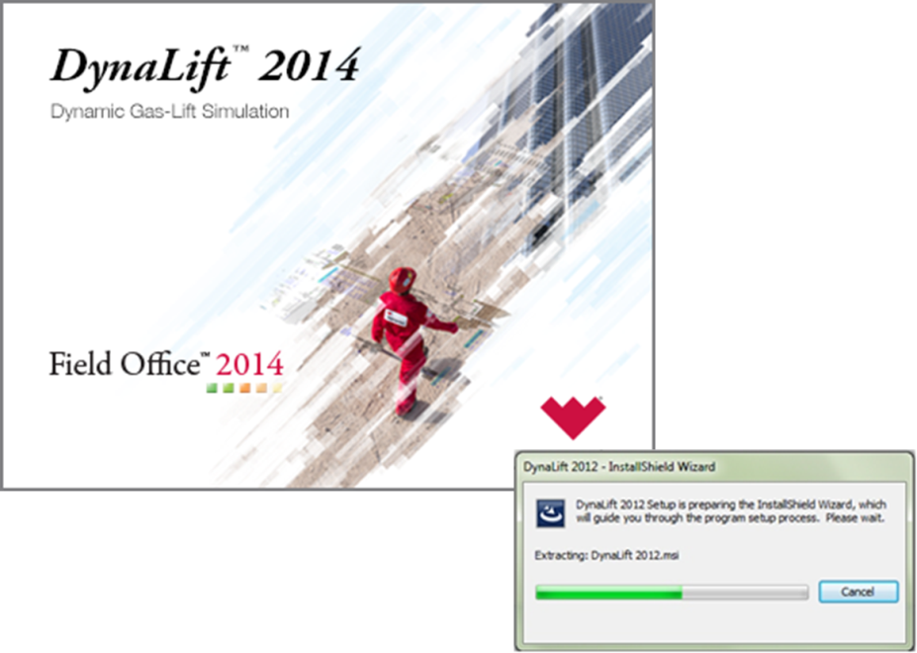

The Welcome screen of installation wizard is displayed as shown in figure below.

Figure: Welcome screen

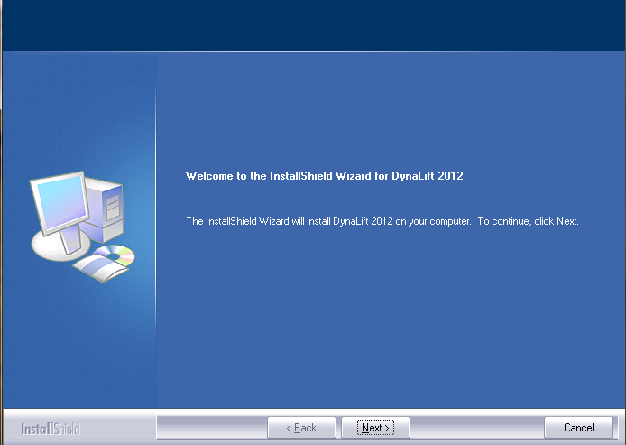

|  |  |
| --- | --- |
|  | If DynaLift application is already present on your computer, it asks to Modify/Repair/Remove the application in the *Welcome* screen of the wizard as shown in screen below:  C:\Documents and Settings\jv_vyasda\Desktop\!doc_tmp_folder_0\dialogInstallation_Welcome_Options.JPG  You can select any of the desired option from the above screen to continue the installation. |

1. Click **Next** to continue with the installation wizard.

The ***Choose Destination Location*** screen of wizard is displayed.

1. Click the **Browse** button and locate the drive location where DynaLift application is to be installed.

Figure: Choose Destination Location

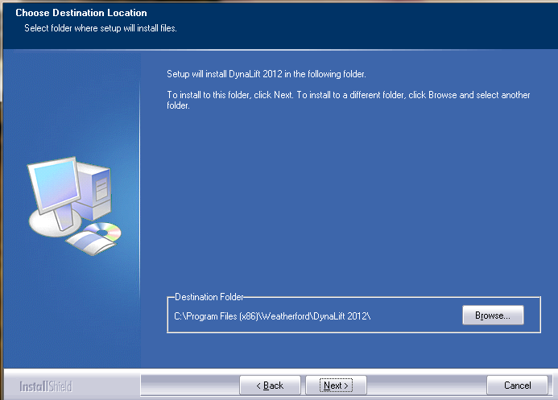

The complete path is displayed under the **Destination Folder** area.

|  |  |
| --- | --- |
| C:\Documents and Settings\jv_vyasda\Desktop\!doc_tmp_folder_0\Note icon.jpg | The Back button is used to navigate to the previous screen and Cancel button is used to abort the installation. |

1. Click **Next** to continue.

The ***Ready******to Install the Program*** screen of wizard is displayed.

Click the **Install** button to install the DynaLift application.

Figure: Ready to Install the Program

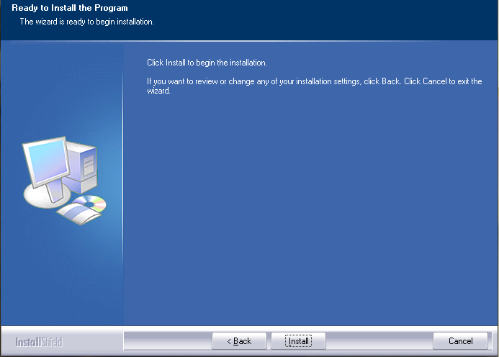

The ***Setup Status*** screen is displayed which shows the installation progress.

Figure: Set-up Status screen

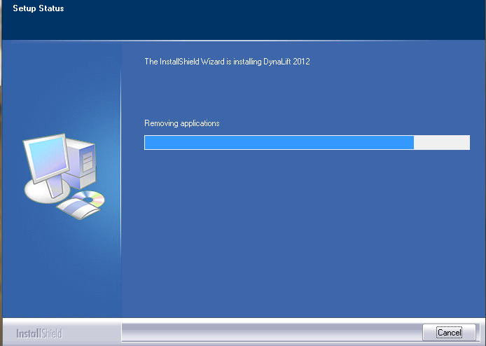

The following screen indicates the completion of installation.

Figure: Installation Complete Screen

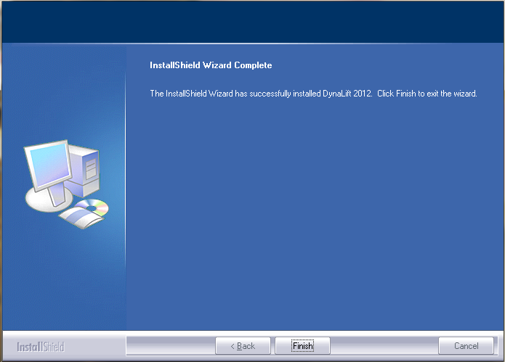

1. Click the **Finish** button to complete the installation process.

|  |  |
| --- | --- |
| C:\Documents and Settings\jv_vyasda\Desktop\!doc_tmp_folder_0\Note icon.jpg | After completing the installation process, the DynaLift application is added to the Start > Program menu and a shortcut is also created on the desktop for quick access to the application. |

DynaLift Workflow

Overview

The typical workflow of DynaLift includes the following steps:

1. **Load DynaLift application**

It includes launching and loading of the DynaLift application by selecting the **Start** > **Programs** > **DynaLift** or click  icon shortcut. For more information, see [Load Dynalift application](file:///C:\Users\e170076\AppData\Local\Temp\Deepa.doc#LoadDynalift) section described later in this topic.

1. **Configure a well model**

It includes [Create a new layout model](file:///C:\Users\e170076\AppData\Local\Temp\Deepa.doc#CreateNewModel) or [open an existing layout model](file:///C:\Users\e170076\AppData\Local\Temp\Deepa.doc#OpeningExistingModel) section. It also includes the configuration of well model such as, *Well Identification*, *Well* and *Flow Type*, *Flow Correlation*, and so on. For more information, see [Configure a Well Model](file:///C:\Users\e170076\AppData\Local\Temp\Deepa.doc#ConfigureWellInfo) section.

1. **Set-up the initialization conditions**

It includes the setting-up the initialization conditions such as, *Annulus* and *Tubing* Gradients, Starting *WellHead Pressure*, *Choke Control Settings*, and so on. For more information, see [Perform Initialization](file:///C:\Users\e170076\AppData\Local\Temp\Deepa.doc#simulation_process) on a well section.

1. **Perform simulation process**

It includes start, pause and terminate the simulation process along with the steps to perform continuous simulation and the condition to perform *auto-save* and *auto-exit*. Also, the parameters controlling the simulation computation are also set in this step. For more information, see [Perform Simulation](file:///C:\Users\e170076\AppData\Local\Temp\Deepa.doc#continuous_initialization)  section.

1. **Generate Reports**

It includes the process of generating summary reports after simulation gets completes. For more information, see [Generate Summary Report](file:///C:\Users\e170076\AppData\Local\Temp\Deepa.doc#SummaryReport) section.

1. **Exit from DynaLift**

It includes the steps for quitting DynaLift application. For more information, see [Exit from DynaLift](file:///C:\Users\e170076\AppData\Local\Temp\Deepa.doc) section described later in this topic

DynaLift Workflow Diagram

The graphical representation of DynaLift workflow is given below:

Load DynaLift Application

* To load the DynaLift application, select **Start** > **Programs** > **DynaLift** or click  short cut (if available). The splash screen followed by the following *StartUp* screen is displayed.

Figure: DynaLift Splash screen

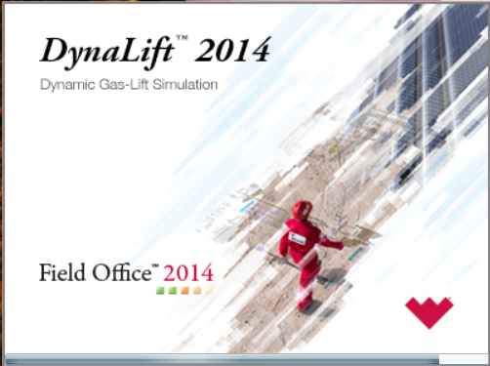

Figure: DynaLift StartUp screen

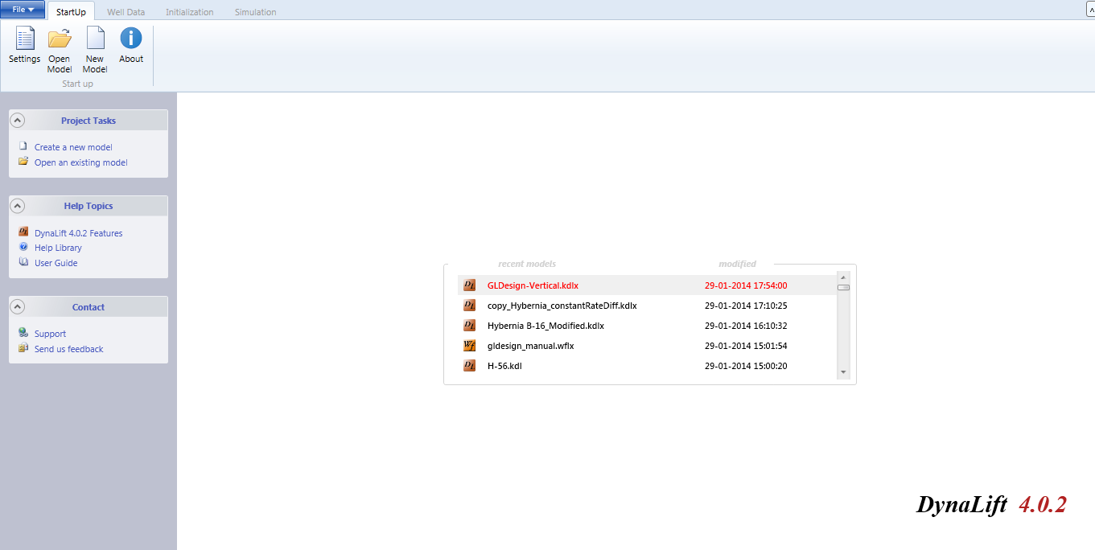

* In the **StartUp** screen, double-click a model file name to open/load the existing well model (See [Figure](file:///C:\Users\e170076\AppData\Local\Temp\Deepa.doc#StartUpScreen) above) from the available model list.

|  |  |
| --- | --- |
| C:\Documents and Settings\jv_vyasda\Desktop\!doc_tmp_folder_0\Note icon.jpg | By default, the StartUp tab and its toolbar are displayed. In the StartUp screen, under recently models, file name with its extension and under modified date and time the date/time of latest modification done, are displayed. |

* For more information about the *StartUp* screen components click [StartUp screen Components](file:///C:\Users\e170076\AppData\Local\Temp\Deepa.doc#StartUPComponent).

StartUp Screen Components

You can perform the following task by using *StartUp* screen panes and toolbar buttons:

**Panes**:

There are three panes available to perform the following task:

* To create/open a project.

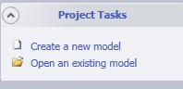

* To retrieve a required help topics.

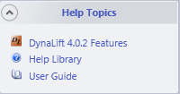

* To contact DynaLift support team and send feedback.

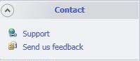

**Toolbar:**

* 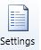**Settings**: Sets a unit system for the current user session. For more information, see [Unit Editor](file:///C:\Users\e170076\AppData\Local\Temp\Deepa.doc#UnitEditor).
* 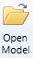**Open Model**: Allows opening an existing Dynalift/WellFlo model. For more information, see [Open existing model](file:///C:\Users\e170076\AppData\Local\Temp\Deepa.doc#OpeningExistingModel).
* 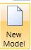**New Model**: Allows creating a new Dynalift model. For more information, see [Create New model](file:///C:\Users\e170076\AppData\Local\Temp\Deepa.doc#CreateNewModel).
* **About**: Shows DynaLift application version.



Exit form DynaLift:

* Select **File** > **Exit** orCtrl**+Q** to exit from DynaLift application.

Figure: Exit from DynaLift

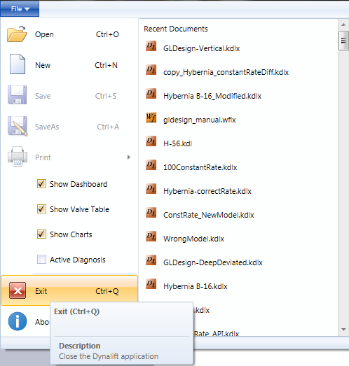

DynaLift Interface

The DynaLift application interface contains the following primary areas that are used to create, view, and configure well data, perform initialization and run simulation. The following is the first screen that displays if you want to create new model and if you want to select well model from existing models.

Basic interface when you create new well model

Figure: DynaLift Start-up screen: Basic interface, if you create new well model

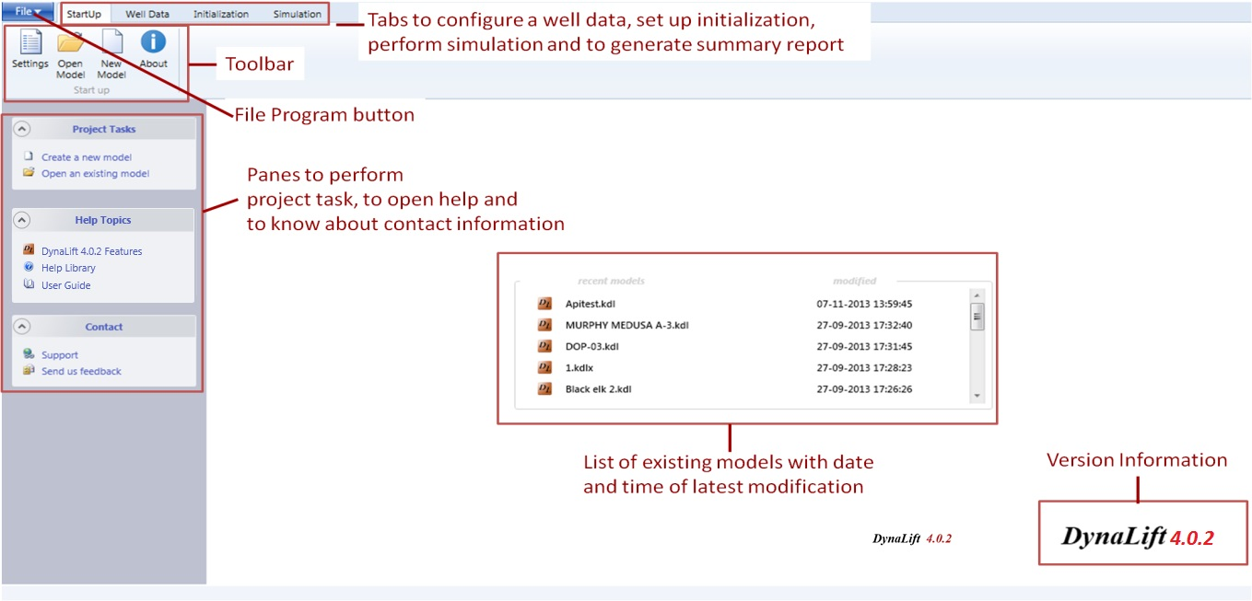

File Program Button

It is used to perform model file related functions,, you can perform the following operations:

Figure: File program button

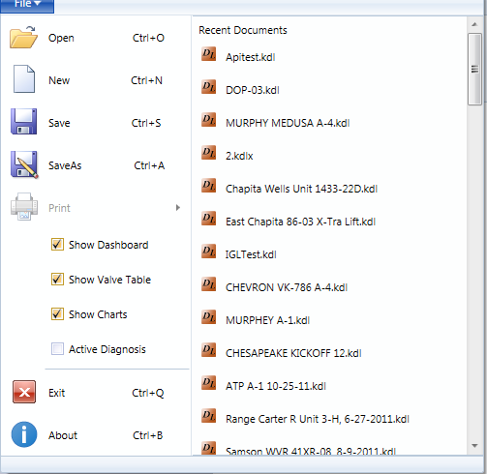

* **Open**: Open an existing well model
* **New**: Create new well model.
* **Save**: Save a well model.
* **Save As**: Save a well with different name.
* **Show Dashboard, Show Valve Table, Show Charts**: These checkbox options are available to show or hide various sections of the simulation screen.
* **Exit**: Exit from DynaLift GUI.
* **About**: Display DynaLift application version.
* **Existing model list**: Open selected model file.

StartUp Screen Components

You can perform the following task by using *StartUp* screen panes and toolbar buttons:

**Panes**

There are three panes available to perform the following task:

* To create/open a project.



* To retrieve a required help topics



* To contact DynaLift support team and send feedback.



**Toolbar**

* **Settings**: Sets a unit system for the current user session. For more information, see Unit Editor.
* **Open Model**: Allows opening an existing DynaLift/WellFlo model. For more information, see Open existing model.
* **New Model**: Allows creating a new DynaLift model. For more information, see Create New model.
* **About**: Shows DynaLift application version.

Tabs

There are different tabs available to perform the following task:

* Well Data: It is used to configure well model, see Well Data tab.
* Initialization: It is used to set-up initialization conditions, see Initialization tab.
* Simulation: It is used to perform simulation, see Simulation tab.

|  |  |
| --- | --- |
| C:\Documents and Settings\jv_vyasda\Desktop\!doc_tmp_folder_0\Note icon.jpg | All the tabs are disabled untill you create a new model or open as existing model. |

Basic interface when you open an existing well model

When you double-click a model file name to open/load an existing well model (See [Figure](file:///C:\Users\e170076\AppData\Local\Temp\DynaLift%20User%20Guide.doc#ExistingWellModels) above) from the available model list in the ***StartUp*** screen, the following screen is displayed when you open an existing well model:

|  |  |
| --- | --- |
| C:\Documents and Settings\jv_vyasda\Desktop\!doc_tmp_folder_0\Note icon.jpg | By default, the StartUp tab and its toolbar are displayed. In the *StartUp* screen, under recently models, file name with its extension and under modified date and time of latest modification are displayed. |

Figure: DynaLift Basic interface, if you open an existing well model

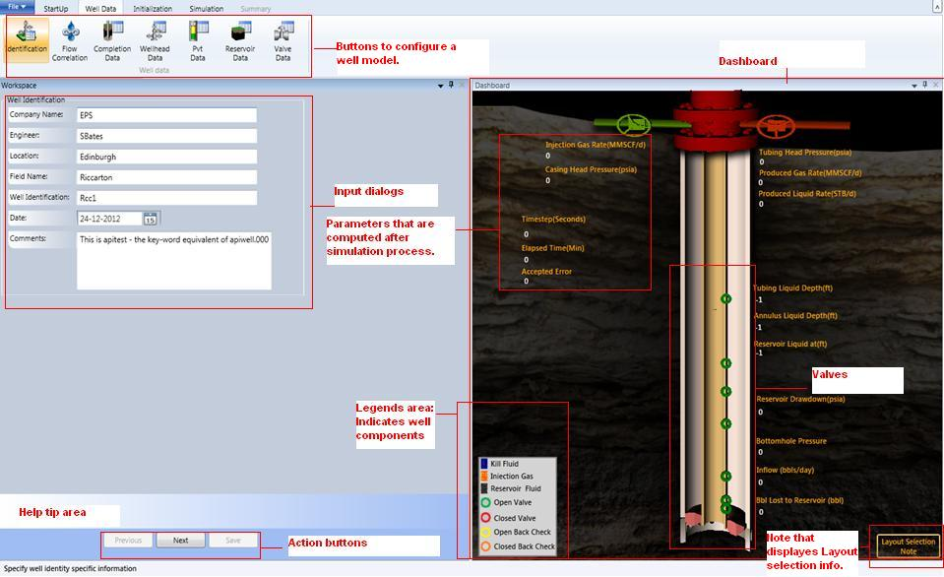

Buttons

The ***Well data*** group buttons are used to configure a well model by *Identification*, *Flow Correlation*, *Completion Data*, *Wellhead Data*, *PVT Data*, *Reservoir Data,* and *Valve Data* button options.

Input dialogs

The input dialog area displays the input fields which are used to enter data for well model configuration.

|  |  |
| --- | --- |
| C:\Documents and Settings\jv_vyasda\Desktop\!doc_tmp_folder_0\Note icon.jpg | The fields values are changed according to the selected unit system in the *Unit Editor* dialog, from StartUp tab > Start up group,> click Setting button > *Unit Editor* dialog. |

Help tip area

The Help tip area displays the information about the selected input field.

|  |  |
| --- | --- |
| C:\Documents and Settings\jv_vyasda\Desktop\!doc_tmp_folder_0\Note icon.jpg | The green tick denotes that the parameters held within a specific dialog (like Wellhead) is valid. |

Dashboard

The dashboard is located on the right side of DynaLift GUI which is a schematic representation of a well. It represents well information and its activities (on simulation) by different graphical objects, colors, and animation. The dashboard properties and parameters are updated while performing Simulation process on a well (See Figure below).

Figure: Dashboard

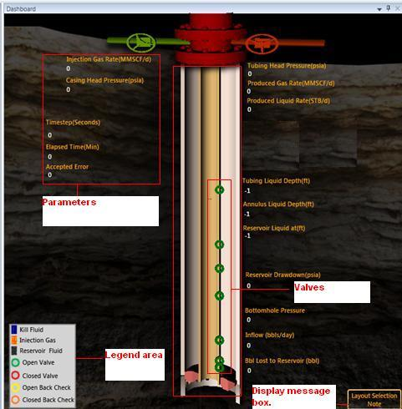

The following parameters are displayed on the dashboard that is updated after simulation process.

**Timesteps (Seconds)**

In the **Timestep** dialog, the timesteps value represents a constant value if, a fixed timestep has been selected, or a changing value if, an automatic timestep has been selected.

**Elapsed Time (Min)**

The Elapsed Time (Min) represents the total real time for which the Simulation has run (not CPU time).

**Produced Liquid Rate (STB/d)**

It represents the liquid rates (STB/d) of produced oil.

**Produced Gas Rate (MMSCF/Day)**

It represents the gas rates (STB/d) of produced gas.

**Injection Gas Rate (MMSCF/Day)**

For Continuous simulation, the value shown here is updated at every time step and is measured in MMSCF/day.

**Annulus Liquid Depth (ft)**

This represents a liquid depth (feet) in the Annulus as calculated at each Timestep. This depth can be compared with the Valve Depths to give an indication of the progress of the Injection Gas in the simulation.

**Bottomhole Pressure (psia)**

It represents calculated Flowing Bottomhole pressure as evaluated at each timestep in psia.

**Inflow (bbls/day)**

It represents liquid produced from the reservoir in Bbls/day (if positive), or lost to (if negative) the reservoir in Bbls/day.

**Tubing Liquid Depth (ft)**

It represents the depth of the liquid in the Tubing as calculated in feet with each Timestep. When this figure reaches zero production commences on surface.

**Reservoir Drawdown (psia)**

It represents the difference between calculated Bottomhole Pressure and Static Bottomhole Pressure in psia specified in the PVT Data dialog. A positive value of Drawdown implies reservoir inflow into the Wellbore. Negative value implies loss of wellbore fluid to the Reservoir.

**Accepted Error**

It represents the difference between the Wellhead Pressure calculated from the Tubing side, and the Wellhead Pressure calculated from Production Choke side. If the difference is over 5 psi, the program iterates to reduce the difference and reports the final difference as the Accepted Error. Large values indicate computational instability, and if they persist, will need a reduction in step size.

**Bbls Lost to Reservoir (bbl)**

For Continuous simulation, it is possible for liquid to be forced back into the Reservoir during the unloading process. The figure listed here shows the cumulative bbls that have been lost to the Reservoir. Should gas lift be effective, this figure will return to zero as production from the reservoir commences. Increasing negative values imply a continuing loss of wellbore liquid to the Reservoir, decreasing positive values imply clean-up, leading to Reservoir Inflow.

**Reservoir Liquid at (ft)**

The depth of reservoir liquid in feet, as opposed to Kill Fluid level, in the tubing as calculated with each Timestep is presented. When this value reaches zero, reservoir fluid starts producing at the surface.

**Head Casing Pressure (psia)**

It represents the value for Casing Head Pressure, and is constantly determined by DynaLift during the Simulate calculations for each Timestep in the calculations.

**Tubing Casing Pressure (psia)**

It represents the pressure of well tubing casing in psia.

Legend area

At the bottom of dashboard, the legend area shows the different types of well content such as Kill Fluid, Injection Gas, Reservoir Fluid, Open, OpenBC and, Closed by different color scheme and objects.

Valves

The valves are also depicted on the dashboard at the particular height of a well.

Layout Selection button

By clicking the **Layout Selection** button, a message box is displayed as shown in screen below that provides the guidelines for creating a new model layout:

Figure: Layout selection-Message box

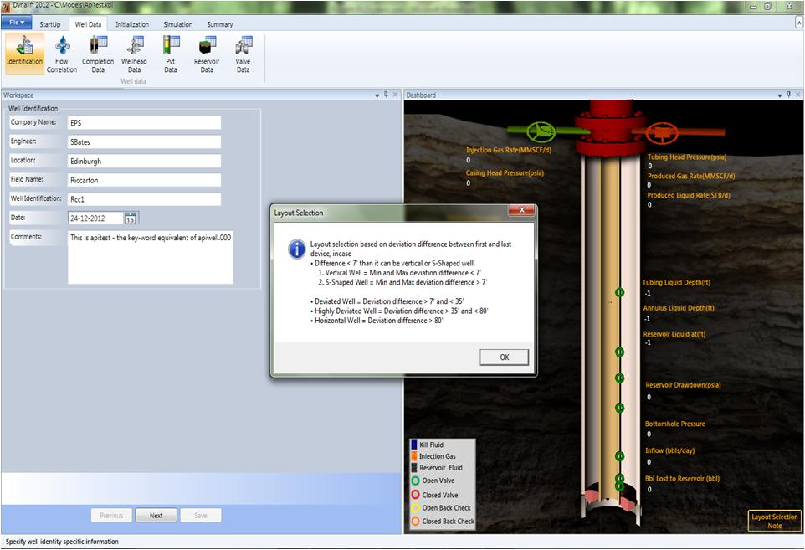

* The message box suggests that the layout selection based on deviation difference between first and last device.
* For creating a new model, considerations are based on deviation information specified in selected layout model file. It is calculated by the difference between calculated deviation value at minimum and maximum depth.
* Below are the assumptions for the layout selection.
  + Deviations < 7 degree => Vertical Well or S-Shaped

|  |  |
| --- | --- |
| C:\Documents and Settings\jv_vyasda\Desktop\!doc_tmp_folder_0\Note icon.jpg | In case deviation is below 7 degree minimum and maximum deviation from all devices to be taken into consideration to calculate the deviation. If it is above 7 degree then it will be considered as S-shaped well. |

* + Deviations > 80 degree -90 degree => Horizontal Well.
  + Deviations > 7 degree  and < 35 degree  => Deviated well
  + Deviations > 35 degree and < 80 degree => Deviated (20 degree) or Highly Deviated Well.

Unit Editor

The **Units Editor** contains a list of supplied unit systems that are currently available. The **Units Editor** is used to set and switch to an alternative units System from the currently selected (i.e. highlighted) unit System for the current user session. Standard sets of *Oilfield* Units and *SI* Units are supplied with DynaLift and these supplied sets cannot be altered.

Unit System Terminology and Rules

It is important that users understand the terminology and associated rules for the ***Units Editor***.

Terms

* Unit. A Unit of measurement (e.g. ft).
* Unit Class. A generic name describing the parameter type or class being measured (e.g. Length).
* Unit System. The complete set of Units assigned, consisting of a Unit for each field name (e.g. the Oilfield Units System, SI (Canada) System, etc.).
* Standard Unit. One Unit in each Unit Class that cannot be edited and comes supplied with the system (e.g. ft in the Length class, psia within the Pressure class).

Rules

* A field name can only be in one Unit Class (e.g. Measured Depth is in the Length class).
* Only one Unit in a Unit Class can be assigned to each data Field Name (e.g. Measured Depth can (obviously) not be in feet and meters at the same time). However, different Units can be assigned to different data Field Names from the same Unit Class (e.g. Flowline length and Flowline inner diameter both have units from the Length class, but one could be assigned in inches, the other in feet, meters, etc.).
* The Unit Systems supplied with DynaLift are locked and cannot be altered.

Selecting Units

The standard sets of Oilfield Units and SI Units are supplied with WellFlo. These supplied sets cannot be altered.

to select a unit:

1. On the **StartUp** tab, in the **Start up** group, click **Setting .**

The *Unit Editor* dialog is displayed (See [Figure](#unit_system_htm_figure:_units_ed_1497) below).

Figure: Units Editor

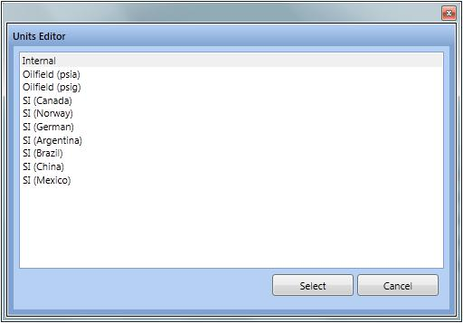

1. Select a unit system from the available unit system list.
2. Click **Select** to set the unit system for all the numeric fields throughout the application or **Cancel** to close the dialog.

Configure Well Information

The **Well Data** tab is used to create, edit, and view gas lifted well information. It includes well identification, flow correlation, completion data, wellhead data, PVT data, reservoir data, and valve data for a well.

The following are the sub-tabs available in the **Well Data** tab to configure well data:

* [Identification](#well_identification_data_htm)
* [Flow Correlation](#flow_correlation_htm)
* [Completion Data](#completion_data_htm)
* [Well Head Data](#well_head_data_htm)
* [PVT Data](#pvt_data_htm)
* [Reservoir Data](#reservoir_data_htm)
* [Valve Data](#valve_data_htm)

Getting Started

To configure a new well, you must first create a new model. Alternatively, you can also open as existing well model.

Create New Well Model:

To create new well model:

1. On the ***StartUp*** screen, click   or select **File** > **New** (**Ctrl+N**) or click **Create a new model** of the **Project Tasks** list located on the left pane of DynaLift application.

By default a vertical well completion is created with a default device of orifice added and perforations also added to the completion. ***Well Identification*** screen of the **Well Data** tab is displayed.

Figure: Vertical-Shaped-Layout shown in the dashboard

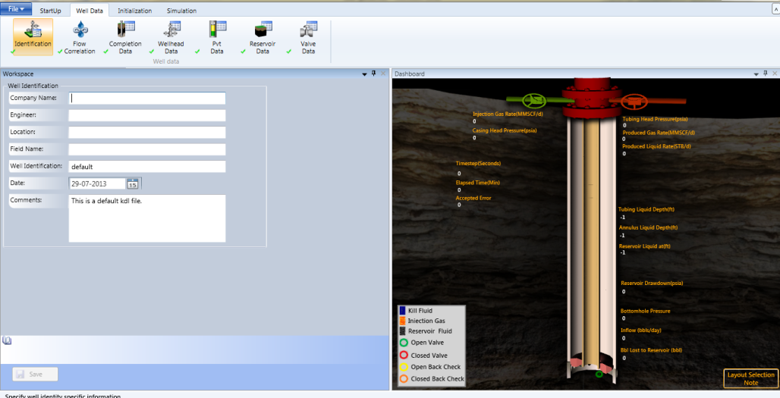

|  |  |
| --- | --- |
| C:\Documents and Settings\jv_vyasda\Desktop\!doc_tmp_folder_0\Note icon.jpg | For a new well model, dashboard shows only one valve. |

1. Select any type of well from given options.
2. Click **OK** to create new well model as .KDLX file.

|  |  |
| --- | --- |
| C:\Documents and Settings\jv_vyasda\Desktop\!doc_tmp_folder_0\Note icon.jpg | Click Previous or Next buttons to navigate to previous and next screens respectively, and the Save button to save input data. |

Opening an Existing Model:

* On the ***StartUp*** screen, Click  button or click the model listed under **recent model** list or select **File** > **Open** or **CTRL+O** (as show in figure below)or click **Open an existing model** of the **Project Tasks** list located in the left pane of DynaLift application.

Figure: DynaLift screen: Opening existing model

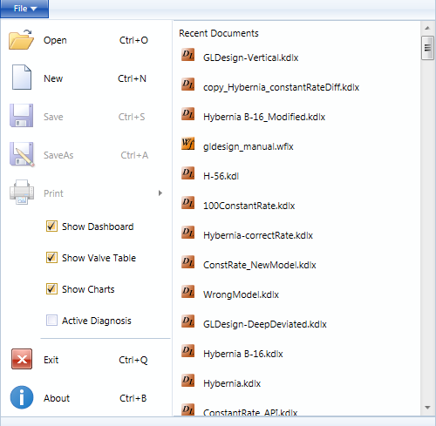

|  |  |
| --- | --- |
| C:\Documents and Settings\jv_vyasda\Desktop\!doc_tmp_folder_0\Note icon.jpg | You can open a specific version of WellFlo model within DynaLift. |

The**Open** Dialog box is displayed (See [Figure](#workflow_htm_figure_:_open_dialo_8771) below).

Figure: Open Dialog box

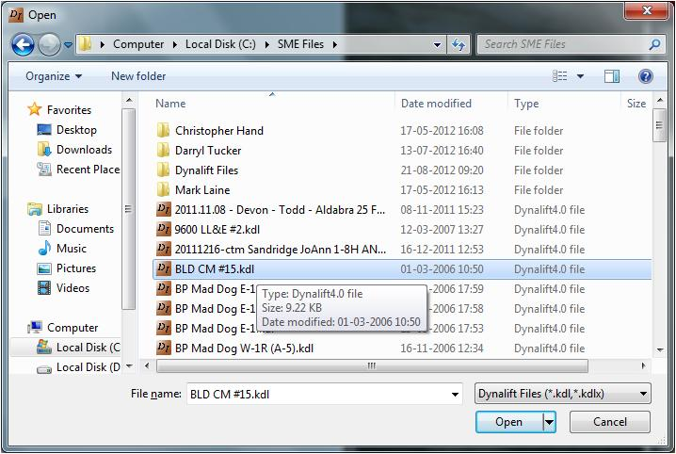

* Select a file to be opened or browse to locate an existing file.

|  |  |
| --- | --- |
| C:\Documents and Settings\jv_vyasda\Desktop\!doc_tmp_folder_0\Note icon.jpg | It supports .KDL, .KDLX, and .WFLX file types. |

Well Identification Data

The **Identification** tab allows recording important details for the Well Model under analysis and identifying a well. This information is stored within the File Header when the file is saved, and will be printed out at the top of any reports.

**Note**: By default, the **Well** **Identification** screen is displayed when you open an existing model.

To edit well identification:

1. Select **Well Data** tab> **Well Data** group > click **Identification**, the ***Well Identification*** screen is displayed (See [Figure](#well_identification_data_htm_fig_9487) below).

Figure: Well Identification dialog

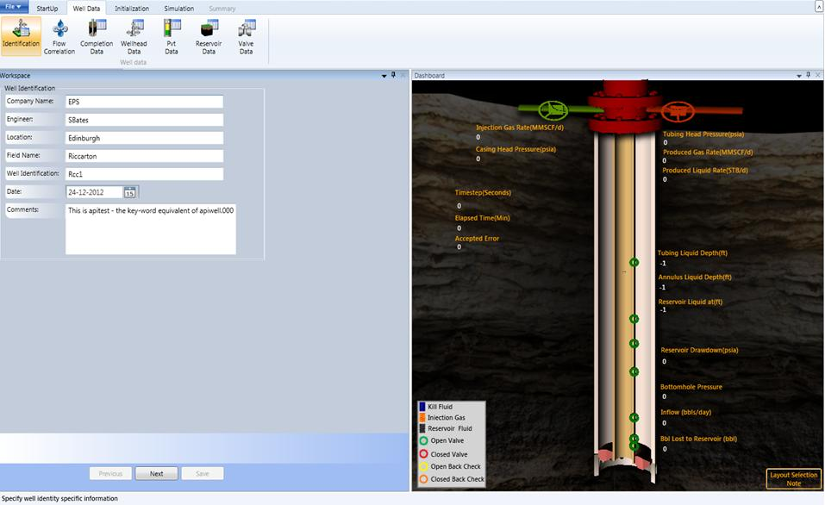

1. Fill in the following data entry fields:

* **Company Name**. The Company name relating to the current well model.
* **Engineer**. The user name.
* **Location**. The geographical location associated with the current well model.
* **Field Name**. The field name associated with the current well model.
* **Well Identification**. The name of a well to be analyzed.
* **Date**. The Date on which the analysis is being performed.
* **Comments**. Additional useful information.

|  |  |  |  |
| --- | --- | --- | --- |
| C:\Documents and Settings\jv_vyasda\Desktop\!doc_tmp_folder_0\Note icon.jpg | The standard Windows keyboard commands to Copy (CTRL+C), Cut (CTRL+X), and Paste (CTRL+V) are also worked here to copy/paste the text. | | |
|  |

1. Click **Next** to navigate to next screen, and click **Save** to save edited information.

Flow Correlation

The ***Flow Correlations*** configuration screen is used to select the Nodal Analysis Correlations to use in the Nodal Analysis calculations. The two categories of correlation can be selected:

• Well and Riser Flow Correlation

• Deep Well Flow Correlation

The L-Factors can be used to calibrate or adjust the Pressure Drop computations in the Well, Pipeline and Sub-Critical Choke sections. During Nodal Analysis, the total Pressure Gradient in each computation increment (i.e. nominally 250 ft), will be multiplied by the value specified for the appropriate L-Factor (i.e. for an L < 1, the computed Pressure Drops will be reduced, and for an L > 1 they will be increased). The Automatic Calibration of L-Factors is described in Automatic L-Factor Calibration

To specify or edit flow correlation:

1. Select **Well Data** tab> **Well Data** group > click **Flow Correlation**, the ***Flow correlation*** screen is displayed (See [Figure](#flow_correlation_htm_figure:_flo_3689) below).

Figure: Flow Correlation

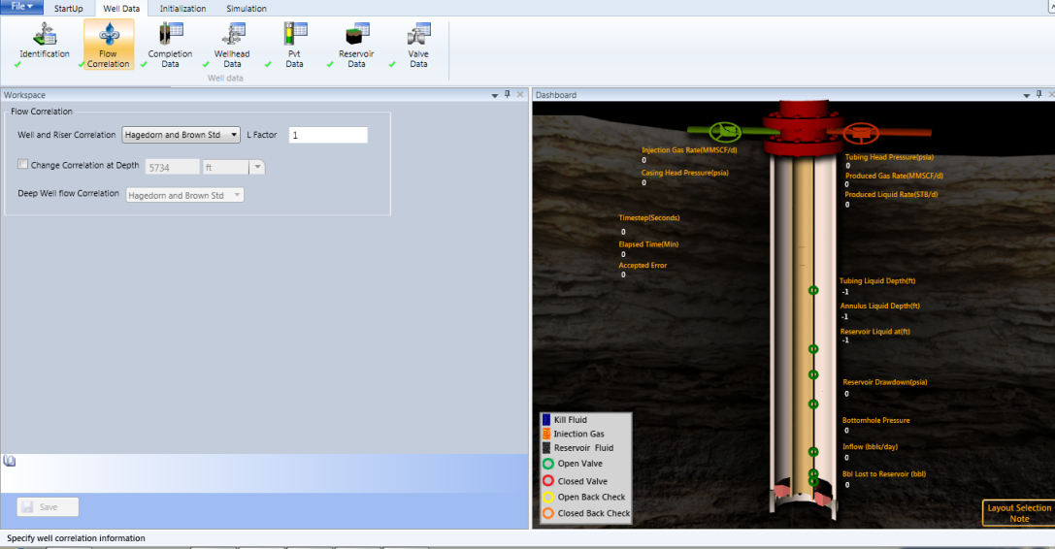

1. Select *Vertical Flow Correlation* from the **Well and Riser Correlation** list and enter a multiplier as L-factor in the **L-Factor** box to apply to all Pressure Drops computed in the ***Well and Riser Components*** (tuning factor).

|  |  |
| --- | --- |
| C:\Documents and Settings\jv_vyasda\Desktop\!doc_tmp_folder_0\Note icon.jpg | Tuning factor “L” is used for the above correlations, if some measured pressure data is available to correct the calculated data, or if you wish to use the same tuning as in WellFlo. The L-factor is used as a multiplier on the pressure gradient computed in each computation increment along the wellbore. A number <1 reduces the gradient, and >1 increases it. |

|  |  |
| --- | --- |
| C:\Documents and Settings\jv_vyasda\Desktop\!doc_tmp_folder_0\Note icon.jpg | Dynalift supports two correlations namely “Hagedorn and Brown std” (default) and “Beggs and brill std”. If the WellFlo model supports "Duns and Ros" correlation, then on opening of WellFlo model it will also take " Hagedorn and Brown std" as default correlation. |

To apply different Flow Correlations in the upper and lower parts of the Well Model, select the **Change Correlation** **at Depth** checkbox and specify a depth with its unit. This could be used to model the horizontal section of a Well with a different Correlation from the Vertical/Slant section.

|  |  |
| --- | --- |
| C:\Documents and Settings\jv_vyasda\Desktop\!doc_tmp_folder_0\Note icon.jpg | The entered value of depth converts according to unit selected from unit drop-down list. When the Change Correlation at Depth checkbox is selected, the Deep Well Flow Correlation list gets enabled. |

* Select optional correlation from the **Deep Well Flow Correlation** list.

|  |  |
| --- | --- |
| C:\Documents and Settings\jv_vyasda\Desktop\!doc_tmp_folder_0\Note icon.jpg | Dynalift supports two correlation namely “Hagedorn and Brown std” (default) and “Beggs and brill std”. If the WellFlo model supports "Duns and Ros" correlation, then on opening of the WellFlo model it will also take " Hagedorn and Brown std" as default correlation. |

Click Previous and **Next** to navigate on previous/next screens respectively, and click **Save** to save edited information.

|  |  |
| --- | --- |
| C:\Documents and Settings\jv_vyasda\Desktop\!doc_tmp_folder_0\Note icon.jpg | Invalid input data is indicated by red color box and X (cross) symbol. The Save button is also disabled on invalid input data. |

Completion Data

The ***Completion Data*** screen is used to view, add, delete, and edit device data in the well. The depths in the table correspond to the positions of “Devices”. The term “Device” includes actual equipment like gas lift valves, or changes in the inner diameter (ID) or angle of deviation. The diameters, depths and angle listed at each depth correspond to the tubing from that depth up to the next highest depth (or up to the wellhead in the case of the top line of the table) (see [Figure](#completion_data_htm_figure:_well_4307) below).In the context of Nodal Analysis, each “Device” is a node.

To specify or edit completion data:

1. Select **Well Data** tab > **Well Data** group > click **Completion Data**, the *Completion Data* screen is displayed (see [Figure](#completion_data_htm_figure:_well_4307) below).

Figure: Well Completion Data

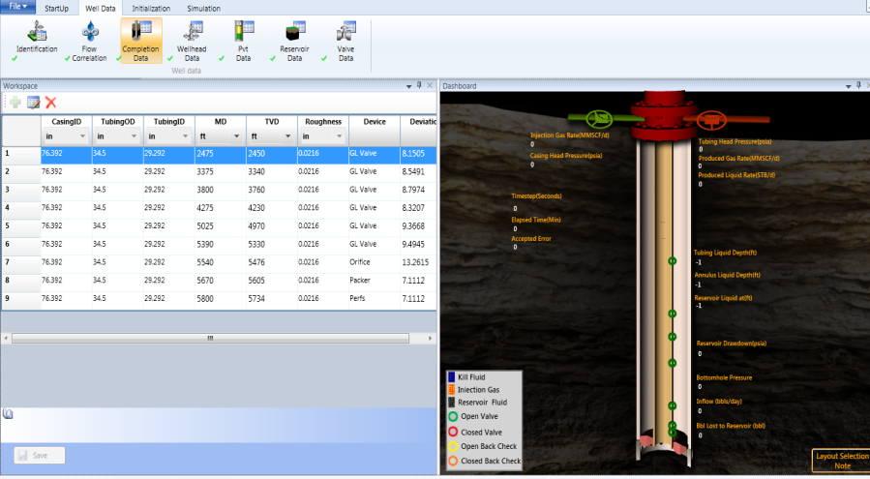

Edit Completion data

You can edit any field with valid data. Invalid input data field of table is indicated by red color box and/or X (cross) symbol. The **Save** button is also disabled on invalid input data.

1. Select a row you want to edit.
2. Modify any of the following fields:
3. **CasingID**: Casing Inner Diameter.
4. **TubingOD**: Tubing Outer Diameter.
5. **TubingID**: Tubing Inner Diameter.

|  |  |
| --- | --- |
| C:\Documents and Settings\jv_vyasda\Desktop\!doc_tmp_folder_0\Note icon.jpg | Tubing outer diameter should not be greater than Casing inner diameter and Tubing inner diameter should also not be greater than Tubing outer diameter. Wrong inputs are indicated by Red box around the row and cross (X) symbol as given in the [Figure](#completion_data_htm_figure:_indi_1361) below. |

Figure: Completion Data: Wrong input in a row

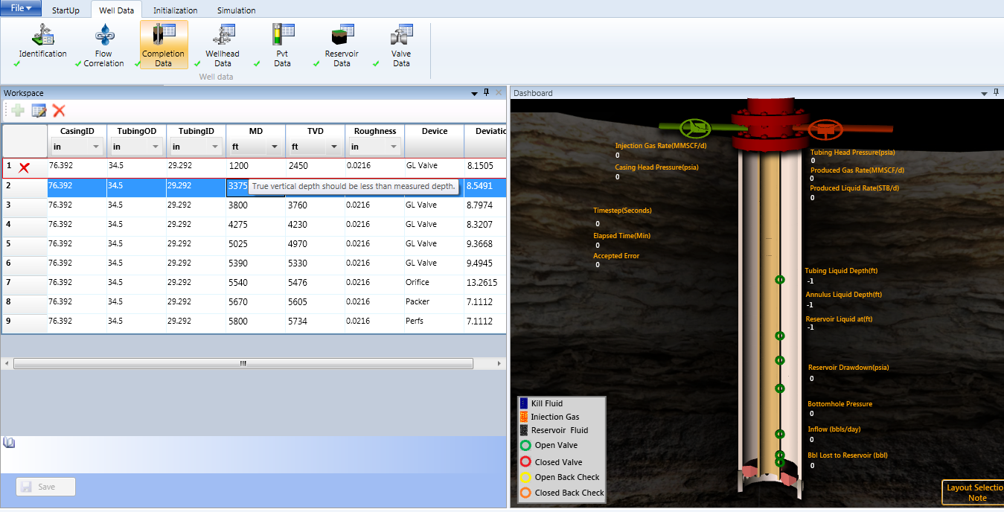

1. **MD**: Measured Depth
2. **TVD**: True vertical depth

|  |  |
| --- | --- |
| C:\Documents and Settings\jv_vyasda\Desktop\!doc_tmp_folder_0\Note icon.jpg | True vertical depth should not be greater than measured depth. Additionally, as the user enters the MD & TVD, the deviation angle should be calculated. Incremental TVD value differences should not be greater than differences in incremental MD values. |

1. **Roughness** (tubing roughness factor - (absolute)): range available: 0.0005” – 0.050”
2. **Devices**: The devices need to be selected from the available list. The devices that are listed are:
   * **Valve** - pressure controlled valve.
   * **Orifice** - orifice valve.
   * **Dummy** - dummy mandrel or any non-specific node.
   * **Packer:** There cannot be any devices below Packer (if it present) except for perforation and packer should be above perforation and orifice should be above packer.
   * **Perfs** - mid-perforation depth. There should not be two perforations. Last device should be perforations. There should be at least one perforation.
   * **Size**: The node at which tubing diameter changes, (when there is no specific piece of equipment present at this depth).
   * **Riser**:
   * **SSSV**: Sub-surface safety valve.
   * **Deviation** - The node at which tubing deviation changes (when there is no specific piece of equipment present at this depth).

|  |  |
| --- | --- |
| C:\Documents and Settings\jv_vyasda\Desktop\!doc_tmp_folder_0\Note icon.jpg | Ensure that the last device in your Completion Data is the *Perfs* data,after that you cannot add any device/data. |

1. Click **Previous** or **Next** to navigate on previous/next screens respectively, and click **Save** to save edited information.

|  |  |
| --- | --- |
| C:\Documents and Settings\jv_vyasda\Desktop\!doc_tmp_folder_0\Note icon.jpg | Invalid input data is indicated by red color box and X (cross) symbol. The Save button is disabled on invalid input data. |

Insert Row to Table

1. Click **Insert Row** button icon.

A blank row is appended at the last row of table.

Figure: Blank row inserted in the table

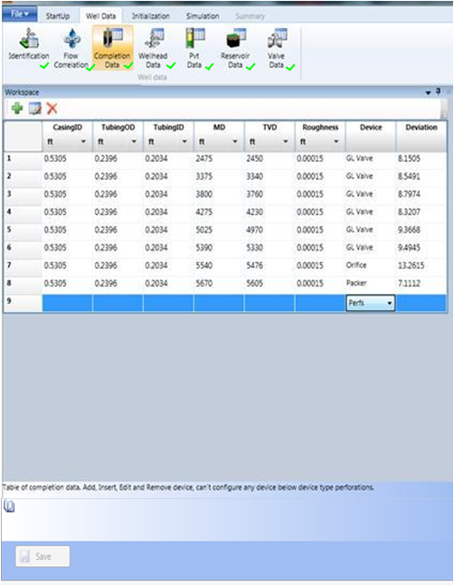

Insert Row Above The Selected Row

1. Click   Insert Row above the selected row button icon.

A blank row is appended above the selected row.

Figure: A blank row inserted in the table



Remove Row

1. Select a row; you want to remove from the table.
2. Click  button to delete a particular row from the table.

All rows below the deleted row will be shifted upward.

Well Head Data

The **Wellhead Data** screen allows you to view, enter, and edit production and injection well head data.

To manage well data:

1. Select **Well** Datatab > **Well Data** group > click **Wellhead Data**, the following screen is displayed (See [Figure](#well_head_data_htm_figure:_wellh_8855) below). This screen contains two sections; **Production** and **Injection**.

Figure: Wellhead Data

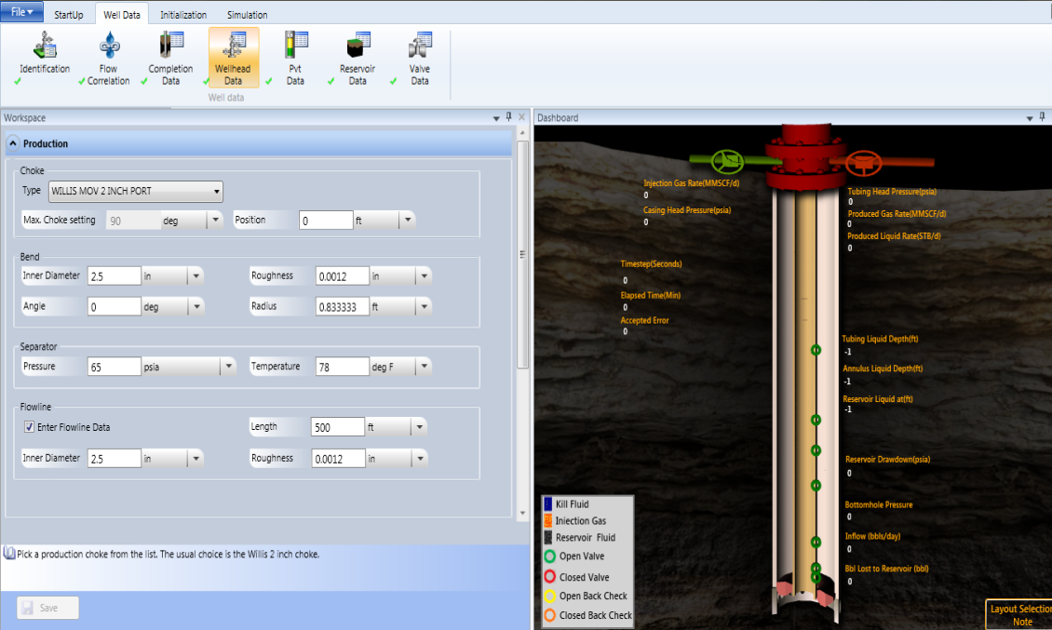

1. In the **Production** area, perform the following steps:
2. Under the **Choke** area, click any one of the following choke type from the **Type** list.

* Generic 5” port: max port size = 160/64” or Flowline ID whichever is smaller.
* Willis MOV 2 port: max setting = 90 (default setting)
* None - no choke is present.

|  |  |
| --- | --- |
| C:\Documents and Settings\jv_vyasda\Desktop\!doc_tmp_folder_0\Note icon.jpg | The selected choke type is displayed in the Selection box. The maximum choke settings are automatically updated for the Max Port size as per the selected choke type and it should be read only. The maximum port size value is updated according to the unit selected. |

1. Enter choke position in feet, the distance between the choke and the wellhead, in the **Choke** box.
2. The **Enter Flowline Data** checkbox should be left unchecked if the user does not have the flow line inputs for the well model.

|  |  |
| --- | --- |
| C:\Documents and Settings\jv_vyasda\Desktop\!doc_tmp_folder_0\Note icon.jpg | The choke position value should be less than flow line length. Invalid input data is indicated by red box and cross (X) symbol around the field as shown below: |

|  |  |
| --- | --- |
| C:\Documents and Settings\jv_vyasda\Desktop\!doc_tmp_folder_0\Note icon.jpg | Range of Max Port Size: Minimum: 0; Maximum: 1000. |

1. Under the Bendarea, enter respective bend data in the following boxes:

* Inner Diameter: The internal diameter of the bend.
* Roughness: The roughness of the bend.
* Angle (degree): The bend angle that turns the flowline, e.g. a right hand bend would be 90 degree, and a u-turn would be 180 degree.
* Radius: The radial distance of the bend from the centre of the bend’s arc to the axial mid line. Therefore, a value of less than half of the diameter cannot occur.

|  |  |
| --- | --- |
| C:\Documents and Settings\jv_vyasda\Desktop\!doc_tmp_folder_0\Note icon.jpg | The value of all the fields in the Well Head Data screen can be converted and displayed according to unit selected by given unit drop-down list. Bend inner diameter should not be greater than bend radius. |

|  |  |
| --- | --- |
| C:\Documents and Settings\jv_vyasda\Desktop\!doc_tmp_folder_0\Note icon.jpg | Range of   * Inner Diameter: Minimum: 0; Maximum: 50 * Roughness: : Minimum: 0; Maximum: 24 * Angle: Minimum: 0; Maximum: 360 * Radius: Minimum: 0; Maximum: 100 |

1. Under the **FlowLine** area, enter respective flowline data in the following boxes:

* Length: Length of the flowline to the separator.
* Inner Diameter: Inner diameter of the flowline. Only one flowline (assumed horizontal) is currently allowed.
* Roughness: Roughness of the flowline.

|  |  |
| --- | --- |
| C:\Documents and Settings\jv_vyasda\Desktop\!doc_tmp_folder_0\Note icon.jpg | Range of:  Length: Minimum: 0; Maximum: 10000.  Inner Diameter: Minimum: 0; Maximum: 120.  Roughness: Minimum: 0; Maximum: 24. |

1. Under the **Separator** area, enter respective separator data in the following boxes:

* Pressure: Separator Pressure
* Temperature: Separator Temperature

|  |  |
| --- | --- |
| C:\Documents and Settings\jv_vyasda\Desktop\!doc_tmp_folder_0\Note icon.jpg | Range of:  Pressure: Minimum: 14.696; Maximum: 20000.  Temperature: Minimum: 0; Maximum: 200. |

1. In the **Injection** data area, perform the following steps:
2. Under the **Choke** area, click any one of the following choke type from the **Type** list.
   * **Merla\_1\_4” port**: max port size = 16/64”
   * **Merla\_1\_2” port**: max port size = 32/64”
   * **Merla\_3\_4” port**: max port size = 48/64”
   * **Merla\_1\_1\_2”port**: max port size = 96/64”

|  |  |
| --- | --- |
| C:\Documents and Settings\jv_vyasda\Desktop\!doc_tmp_folder_0\Note icon.jpg | The selected choke type is displayed in the Selection box. The maximum choke settings get automatically updated for the Max Port size as per the selected choke type and it should be read only. The maximum port size value is updated according to the unit selected. |

|  |  |
| --- | --- |
| C:\Documents and Settings\jv_vyasda\Desktop\!doc_tmp_folder_0\Note icon.jpg | The injection choke information is not retrieved from .WFLX file. It sets programmatically in the Dynalift application. |

1. Under the **FlowLine** area, enter respective flowline data in the following boxes:
   * **Length**: Length of the injection flowline from the injection choke to the casing head.
   * **Inner Diameter**: Inner diameter of the injection flowline. Only one flowline (assumed horizontal) is currently allowed.
2. Under the **Injection Parameters** area, enter the following parameters:
   * **Gas Temp**: Injection Gas Temperature on surface.
   * **Avail Pressure**: Maximum pressure available upstream of the injection choke.
   * **Maximum Injec**: Maximum amount of injection gas available for kick-off.

|  |  |
| --- | --- |
| C:\Documents and Settings\jv_vyasda\Desktop\!doc_tmp_folder_0\Note icon.jpg | Range of  Max Port Setting: Minimum: 0; Maximum:1000.  Gas Temp: Minimum: 1; Maximum: 15000.  Avail Pressure: Minimum: 0; Maximum: 20000.  Max Injection Rate: Minimum: 0; Maximum: 100000.  Flowline Length: Minimum: 0; Maximum: 10000.  Flowline Inner Diameter: Minimum: 0; Maximum: 120. |

|  |  |
| --- | --- |
|  |  |

1. Click **Previous** or **Next** are used to navigate on previous/next screens respectively, and click **Save** to save edited information.

|  |  |
| --- | --- |
| C:\Documents and Settings\jv_vyasda\Desktop\!doc_tmp_folder_0\Note icon.jpg | Invalid input data is indicated by red color box and X (cross) symbol. The Save button is also disabled on invalid input data. |
| C:\Documents and Settings\jv_vyasda\Desktop\!doc_tmp_folder_0\Note icon.jpg | The unit values for above all inputs can be selected from the drop-down list. |

PVT Data

The **PVT Data** screen allows you to specify fluid gravities, gas composition, and fluid correlation of a well.

To specify pvt data:

1. Select **Well Data** tab> **Well Data** group> click **PVT Data** , the following screen is displayed (See [Figure](#pvt_data_htm_figure:_pvt_data) below). This screen contains four sections; **Fluid Gravities**, **Gas Composition**, **Fluid Correlation**,and **Results**.

Figure: PVT Data

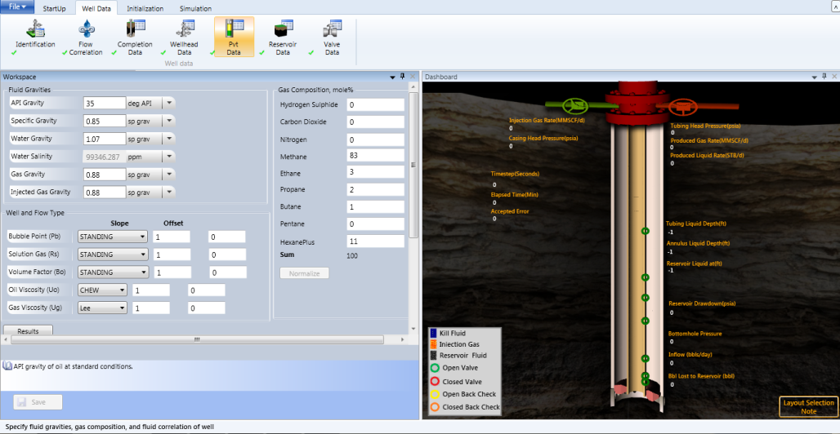

1. In the **Fluid Gravities** area, perform the following steps:
2. Enter the stock tank API gravity of the oil in the **API Gravity** box, accordingly the value of **Specific Gravity** is automatically calculated and if user enters **Specific Gravity**,value, then **API Gravity** is automatically calculated.
3. Enter specific gravity of produced water in **the Water Gravity** box. The value of *Water Salinity* is automatically calculated. If you enter *Water Salinity* value, then *Water Gravity* is automatically calculated.
4. Enter specific gravity of associated gas at standard conditions (air = 1.0) in the **Gas Gravity** box.
5. Enter specific gravity of injected gas at standard conditions (air = 1.0) in the **Injected Gas Gravity** box.

|  |  |
| --- | --- |
| C:\Documents and Settings\jv_vyasda\Desktop\!doc_tmp_folder_0\Note icon.jpg | Select a unit from the list of unit associated with API Gravity, Specific Gravity, Water Gravity, Water Salinity, Gas Gravity, Injected Gas Gravity fields. |

|  |  |
| --- | --- |
| C:\Documents and Settings\jv_vyasda\Desktop\!doc_tmp_folder_0\Note icon.jpg | *API* gravity and *Sgo* are interdependent. As user enters one value, the other one is calculated.  Water gravity and salinity are also interdependent, hence one value is updated based on the other value provided. |

|  |  |
| --- | --- |
| C:\Documents and Settings\jv_vyasda\Desktop\!doc_tmp_folder_0\Note icon.jpg | Range of  API Gravity: Minimum: 5; Maximum:151.5.  Specific Gravity: Minimum: 0.5; Maximum: 1.036.  Water Gravity : Minimum: 0.999; Maximum: 1.415.  Water Salinity: Minimum: 0; Maximum: 500000.  Gas Gravity: Minimum: 0.5; Maximum: 1.6.  Injected Gas Gravity: Minimum: 0.5; Maximum: 1.6. |

1. In **the Gas Composition, mole %** area, perform the following steps:
2. Enter a value in the **Hydrogen Sulphide** box.
3. Enter a value in theCarbon **Dioxide** box.
4. Enter a value in the Nitrogen box.
5. Enter a value in the Methane box.
6. Enter a value in the Ethanes box.
7. Enter a value in the Propane box.
8. Enter a value in the **Butanes** box.
9. Enter a value in the **Pentanes** box.
10. Enter a value in the **Hexanes Plus** box.

|  |  |
| --- | --- |
| C:\Documents and Settings\jv_vyasda\Desktop\!doc_tmp_folder_0\Note icon.jpg | Total gas composition should be equal to 100. |

1. In the **Well and Flow Type** area, perform the following steps:
2. Select different correlations from given correlation list. The following are the different correlations available:
   * **Pb, Rs, Bo (Bubblepoint, Solution Gas Oil Ratio, and Oil Formation Volume Factor)**: Glaso, Schmidt (Schmidt and Kartoatmodjo), Vazquez (Vazquez and Beggs), Standing, Lasater.
   * **Uo (Oil Viscosity**): Beggs (Beggs and Robinson), Schmidt (Schmidt and Kartoatmodjo), Chew (Chew and Conally).
   * **Ug (Gas Viscosity)**: Carr, et al (Carr, Kobayashi and Burrows) and Lee, et al (Lee, Gonzalez and Eakin).
   * **Volume Factor**: Glaso, Schmidt (Schmidt and Kartoatmodjo), Vazquez (Vazquez and Beggs), and Standing, Marhoun.

|  |  |
| --- | --- |
| C:\Documents and Settings\jv_vyasda\Desktop\!doc_tmp_folder_0\Note icon.jpg | The correlations can also be tuned. This may be done by entering a known slope and a known offset (shift). Straight-line relationship (corrected = (slope \* calculated) + offset) is applied. |

1. Also, enter slope and offset values of corresponding correlation in the **Slope** and **Offset** boxes respectively.

|  |  |
| --- | --- |
| C:\Documents and Settings\jv_vyasda\Desktop\!doc_tmp_folder_0\Note icon.jpg | Invalid input data is indicated by red color box and X (cross) symbol. The Save button is also disabled on invalid input data. |

1. Click **Results** to display corresponding result data in the **Results** area.

Following result data are displayed (See [Figure](#pvt_data_htm_figure:_pvt_data_re_5866) below).

Figure: PVT Data Result

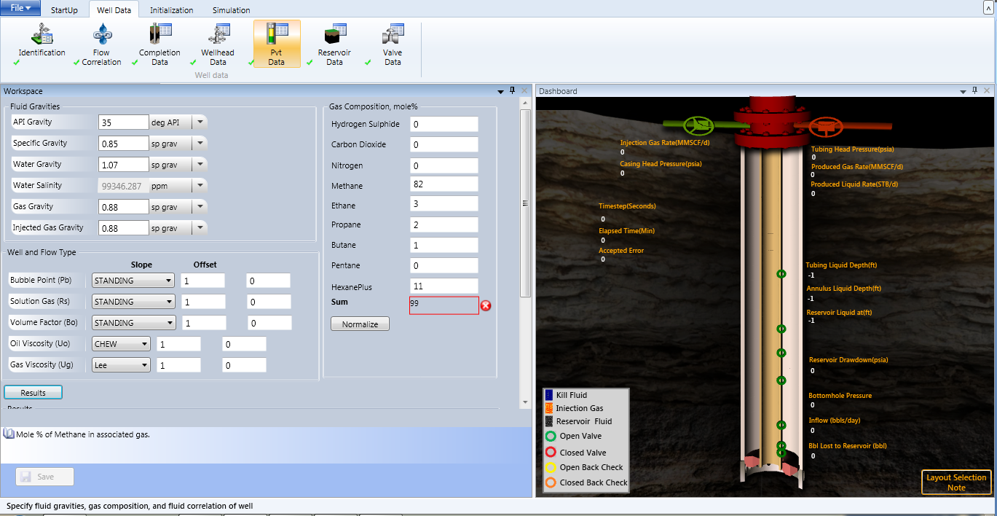

The **Results** area contains the following field values:

* + Bubble Point : (psia)
  + Solution GOR : (SCF/STB)
  + Reservoir Free Gas : (MSCF/day) = (Prod GOR - Solution GOR) x Oil Flowrate x 1E-03
* Click *arrow* button to expand and collapse the field information at *Reservoir Conditions* and *Separator Conditions*.

Additionally, the following fields are also computed at ***Reservoir Conditions***:

* Oil Specific Gravity
* Gas Specific Gravity
* Formation Volume Factor of Oil
* Molecular Weight of Oil
* Surface Tension (liquid/gas interfacial tension (dynes/cm))
* Oil Viscosity (cp)
* Gas Viscosity (cp)

The following fields are computed at ***Separator Condition*s**:

* Oil Viscosity (cp)
* Gas Viscosity (cp)
* Surface Tension (liquid/gas interfacial tension (dynes/cm))

1. Click **Normalize**, if you want to normalize gas composition; the warning message box is popped-up before performing normalization.

|  |  |
| --- | --- |
| C:\Documents and Settings\jv_vyasda\Desktop\!doc_tmp_folder_0\Note icon.jpg | The unit of the PVT Data can be converted and displayed according to unit selected by given unit drop-down list. |

1. Click **Save** to save entered data.
2. Click **Next** to navigate on the next screen or **Previous** to navigate on the previous screen/tab.

Reservoir Data

The **Reservoir Data** screen contains four sections; **Reservoir Data**, **IPR Data, Temperature Data**,and **Results**. The screen allows user to generate result such as **AOF** and **Productivity index** based on the data entered on these different sections.

The **Reservoir Data** screen allows the user to:

1. Specify **Reservoir conditions** in the **Reservoir Data** section such as **pressure**, **temperature**, **injectivity**, **flow** **efficiency**, **water** **cut**, and **GOR**.
2. Specify **Geo** **gradient** in the **Temperature Data section.**
3. Specify test data or manual data in the **IPR** section
   * For **Test** data, enter **Flowing BHP** and **Liquid Rate**.
   * For **Manual** data, enter **Productivity** **Index**.
4. Generate results for **AOF** and **Productivity Index**.
   * If user requires AOF, then enter Manual data on the screen.
   * If user requires **AOF** and **Productivity** **Index**, then enter **Test data** on the screen.

To specify Reservoir Conditions:

1. Select **Well Data** tab> **Well Data** group> click **Reservoir Data**, the following screen is displayed (See [Figure](#reservoir_data_htm_figure:_reser_1517) below).

Note: The IPR Model field is currently set as *Vogel*.

Figure: Reservoir Data

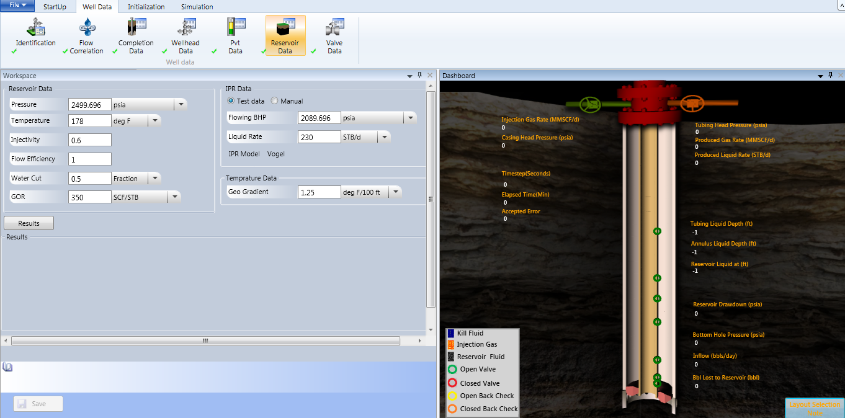

1. In the **Reservoir Data** section, perform the following steps:
2. Enter a reservoir pressure in the **Pressure** box and then select unit from the list.
3. Enter a reservoir temperature in the **Temperature** box and then select unit from the list.
4. Enter an injectivity index of the reservoir in the **Injectivity** box.
5. Enter a flow efficiency of reservoir in the **Flow Efficiency** box.

|  |  |
| --- | --- |
| C:\Documents and Settings\jv_vyasda\Desktop\!doc_tmp_folder_0\Note icon.jpg | Use a value of 1.0 if unrestricted flow from the reservoir. For reservoirs with damage a value less than 1.0 should be used. |

1. Enter a water cut of reservoir in the **Water** **Cut** box and then select unit from the list.
2. Enter a gas oil ratio of reservoir in the **GOR** box and then select unit from the list.

|  |  |
| --- | --- |
| C:\Documents and Settings\jv_vyasda\Desktop\!doc_tmp_folder_0\Note icon.jpg | Range of:  Pressure: Minimum 14.696; Maximum 10013.7  Temperature: Minimum: 60; Maximum:1000  Injectivity: Minimum: 0; Maximum: 1000  Flow Efficiency: Minimum: 0; Maximum: 1000  Water Cut: Minimum: 0; Maximum: 1  Prod GOR: Minimum: 0; Maximum: 200000  Liquid Rate: Minimum: 0; Maximum: 32767 |

1. In the **IPR Data** section, perform the following steps:

IPR data section allows the user to enter test data or manual data.

For Test Data, perform the following steps:

1. Select the **Test Data** option button ([Ref Fig below](#RH_PD_TOC_BKtestdata)).
2. Enter flowing BHP rate in the **Flowing BHP** box**,** and then select unit system ([Ref Fig below](#RH_PD_TOC_BKtestdata)).
3. Enter liquid rate in the **Liquid Rate** box**,** and then select unit system ([Ref Fig below](#RH_PD_TOC_BKtestdata)).

Figure: Test Data



|  |  |
| --- | --- |
| C:\Documents and Settings\jv_vyasda\Desktop\!doc_tmp_folder_0\Note icon.jpg | Total gas production rate (MSCF/day) as Gas Flowrate during the recent welltest (including injection gas), automatically updated from a given producing GOR, oil rate and injection gas rate. The field is read-only field. |

1. In the **Temperature a**rea, perform the following steps:
2. Enter geo gradient temperature in the **Geo Gradient** temperature box.

|  |  |
| --- | --- |
| C:\Documents and Settings\jv_vyasda\Desktop\!doc_tmp_folder_0\Note icon.jpg | The BHSP, BHFP and Well Test Data are used to define the Productivity Index of the well. Bottom hole flowing pressure should not be greater than bottom hole static pressure. |

|  |  |
| --- | --- |
| C:\Documents and Settings\jv_vyasda\Desktop\!doc_tmp_folder_0\Note icon.jpg | Select a unit from the list of unit associated with Bottomhole Flowing, Bottomhole Static, and Wellhead Flowing. |

|  |  |
| --- | --- |
| C:\Documents and Settings\jv_vyasda\Desktop\!doc_tmp_folder_0\Note icon.jpg | Range of  Bottomhole Flowing: Minimum:14.696; Maximum:20000 |

1. Click **Result**.

Result will be generated based on the test data ([Ref Figure below](#RH_PD_TOC_BKresult)):

Figure: Result

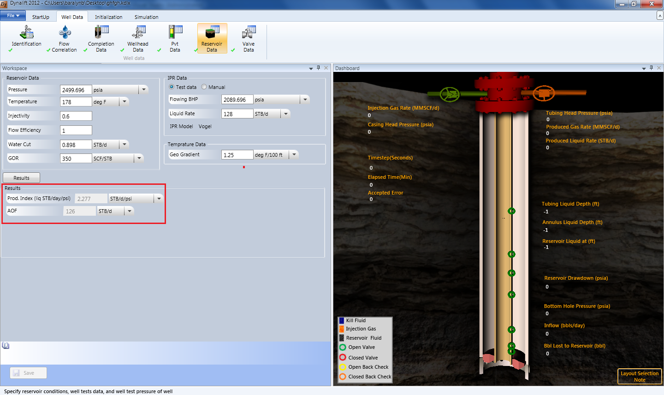

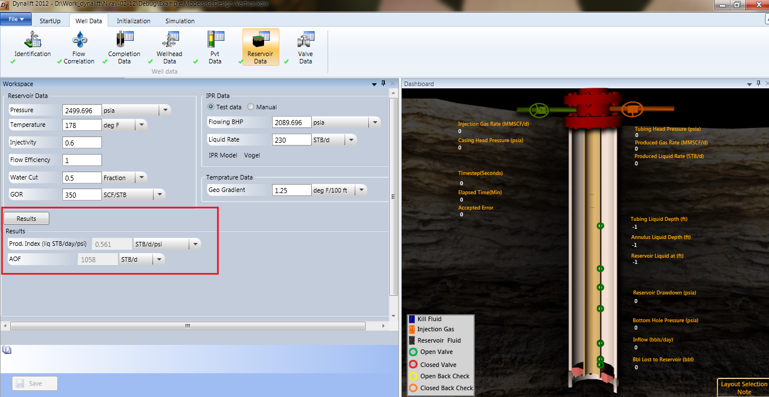

For manual data, perform the following steps:

1. In the **IPR Data** section, perform the following steps:
2. Select the **Manual** option button ([Ref Fig. below](#RH_PD_TOC_BKmanualdata)).
3. Enter production index in the **Prod. Index** box**,** and then select unit system ([Ref Fig. below](#RH_PD_TOC_BKmanualdata)).

Figure: Manual Data

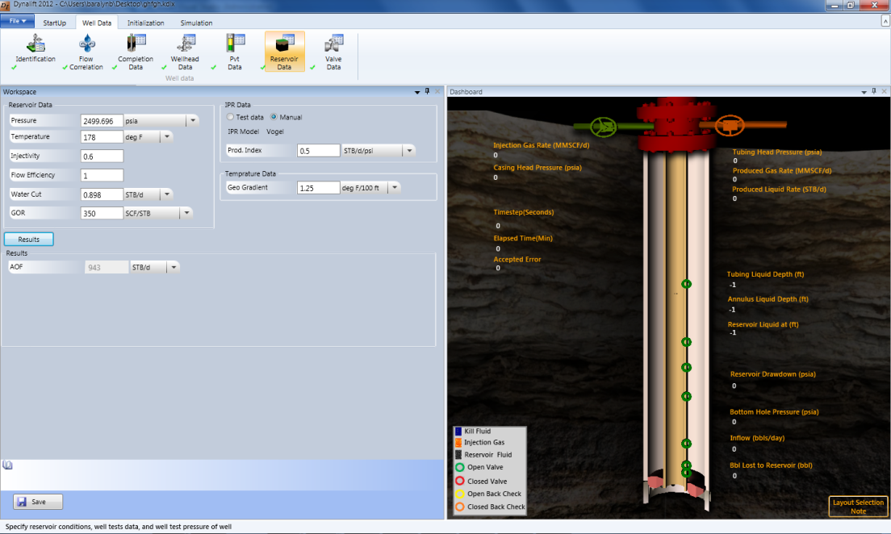

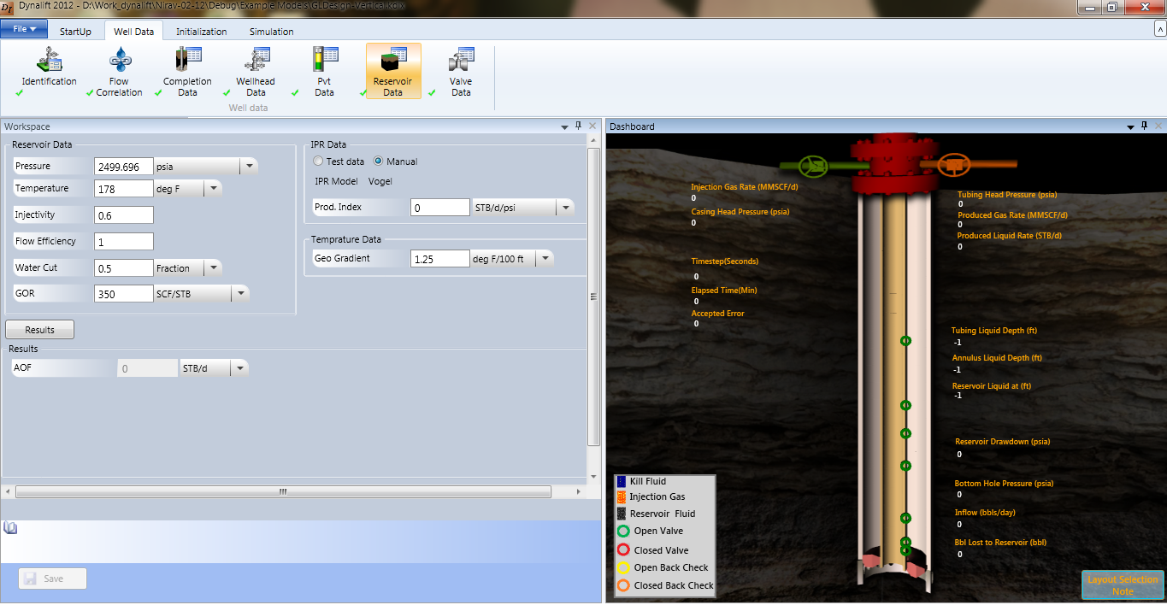

1. In the **Temperature a**rea, perform the following steps:
2. Enter geo gradient temperature in the **Geo Gradient** temperature box.
3. Click **Result**.

DynaLift computes reservoir results based on the data entered. The resultant values are displayed in the **Results** area as shown in [figure below:](#RH_PD_TOC_BKresult1)

Figure: Reservoir Data Result

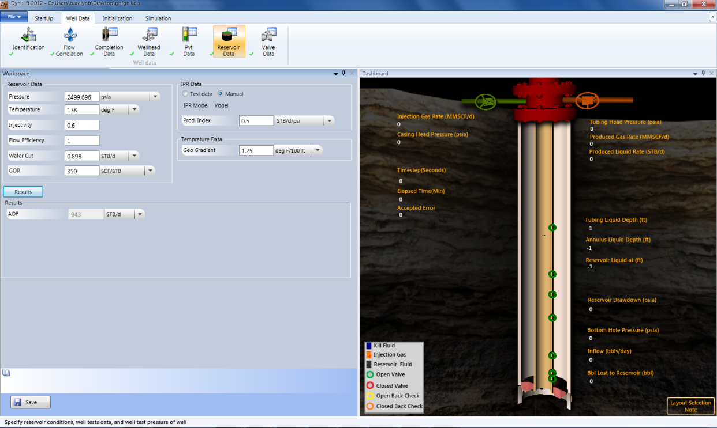



1. Click **Save** to save entered data.

Valve Data

The **Valve Data** screen allows you to edit and view valve information that is created in the **Completion Data** option. Some valve data are proprietary and not available for general release. DynaLift supports only licensed valves.

|  |  |
| --- | --- |
| C:\Documents and Settings\jv_vyasda\Desktop\!doc_tmp_folder_0\Note icon.jpg | The valve data option does not create new valve. It allows only viewing and editing existing valves. |

To view valve data:

1. Select Well **Data** tab> **Well Data** group > click **Valve** **Data**, the following screen is displayed (See [Figure](#valve_data_htm_figure:_valve_dat_2020) below).

Figure: Valve Data

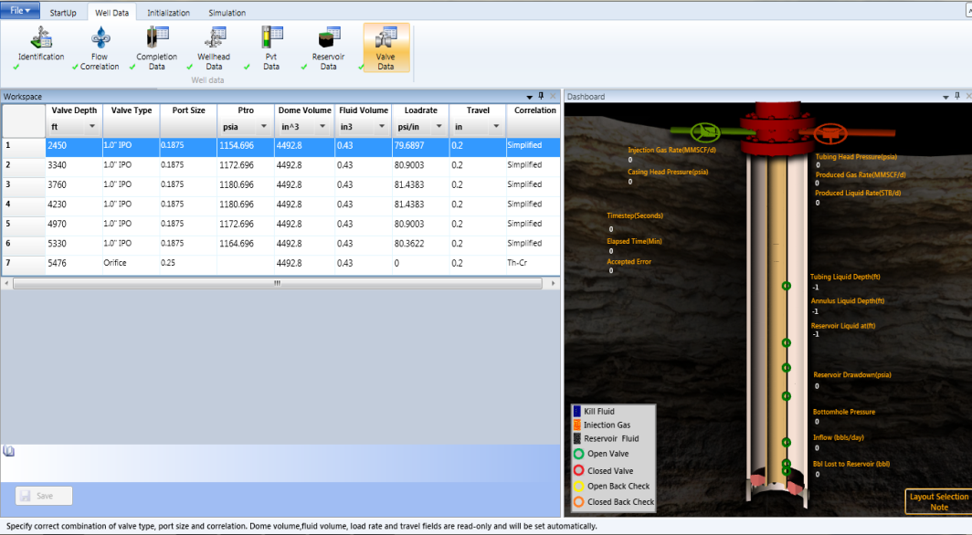

1. Following are the details of table columns:

|  |  |
| --- | --- |
| **Column name** | **Description** |
| Valve Depth | A read-only value of *valve depth* that populates automatically from the completion data screen. |
| Valve Type | Select the type of valve from the list. |
| Port Size | Select the port size from the list. |
| Ptro (Test Rack Opening Pressure) | Enter a value in the box. |
| Dome Volume | A read-only value of *volume of dome*. |
| Fluid Volume | A read-only value of *fluid volume*. |
| Load Rate | A read-only value of v*alve load rate*, is calculated for the specified **Ptro**. |
| Travel | A read-only value of *travel.* |
| Correlation | Select a valve performance correlation from the list. Various correlations are available for the different valves:  **VPC** - Calculated from new test data provided by the Valve Performance Clearinghouse. Available by licence only.  **VPC-TUALP** - Based on a reprocessing of the original TUALP data by the Valve Performance Clearinghouse.  **Winkler-Eads**  **Bertovic**  **Th-Cr** - Thornhill and Craver correlation for a square edged orifice.  **Simplified** - A good general correlation better suited to throttling valves than Thornhill and Craver. |

1. Double-click the fields to be edited such as, **Valve Type**, **Port Size**, **Ptro** and, **Correlation**. The value of read only fields are populated from catalog files, not calculated automatically.

Click **Previous** or **Next** to navigate on the previous/next screens respectively, and click **Save** to save edited information.

|  |  |
| --- | --- |
| C:\Documents and Settings\jv_vyasda\Desktop\!doc_tmp_folder_0\Note icon.jpg | Invalid input data is indicated by red color box and X (cross) symbol. The Save button is also disabled on invalid input data. |

|  |  |
| --- | --- |
| C:\Documents and Settings\jv_vyasda\Desktop\!doc_tmp_folder_0\Note icon.jpg | The value of *Valve Data* is reflected on the dashboard. |

To edit valve data:

User can edit valve information from the dashboard as well.

1. Select and click a valve on the dashboard.

The ***Edit Valve Data*** dialog is displayed (See [Figure](#valve_data_htm_figure:_edit_valv_241) below).

Figure: Edit Valve Data Dialog on Dashboard

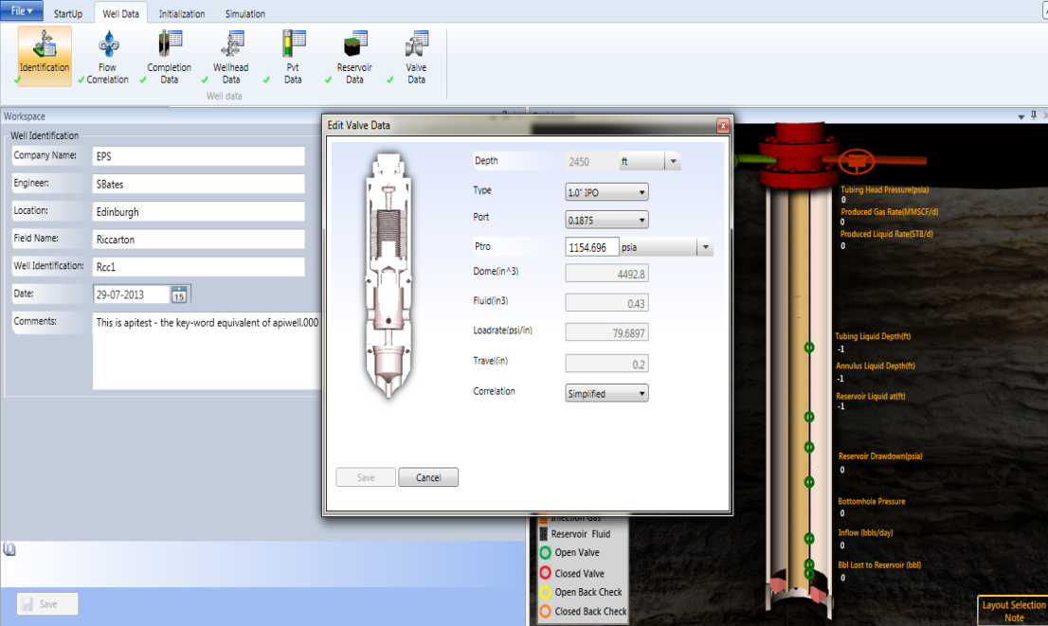

1. Edit the value of the **Type**, **Port**, **Ptro**, and **Correlation** field(s).

|  |  |
| --- | --- |
| C:\Documents and Settings\jv_vyasda\Desktop\!doc_tmp_folder_0\Note icon.jpg | The other fields such as, Depths, Dome, Fluid, Loadrate, and Travel are read-only fields. |

1. Click **Save** to save edited valve information.

|  |  |
| --- | --- |
| C:\Documents and Settings\jv_vyasda\Desktop\!doc_tmp_folder_0\Note icon.jpg | The unit of the Valve Data can be set and populated according to unit selected in the unit drop-down list. |

Initializing DynaLift

Continuous Initialization

The Continuous **Initialization** screen is used to specify the initial conditions of a continuous gas lifted well by giving initial fluid levels, starting pressures, injection method, and initial choke settings.

|  |  |
| --- | --- |
| C:\Documents and Settings\jv_vyasda\Desktop\!doc_tmp_folder_0\Note icon.jpg | Starting injection pressure in the initialization cannot be greater than available pressure in wellhead section. |

 To perform continuous initialization:

1. Select **Initialization** tab> **Initialization** group > **Continuous**, the following screen is displayed (See [Figure](#continuous_initialization_htm_fi_9563) below).

Figure: Continuous Initialization

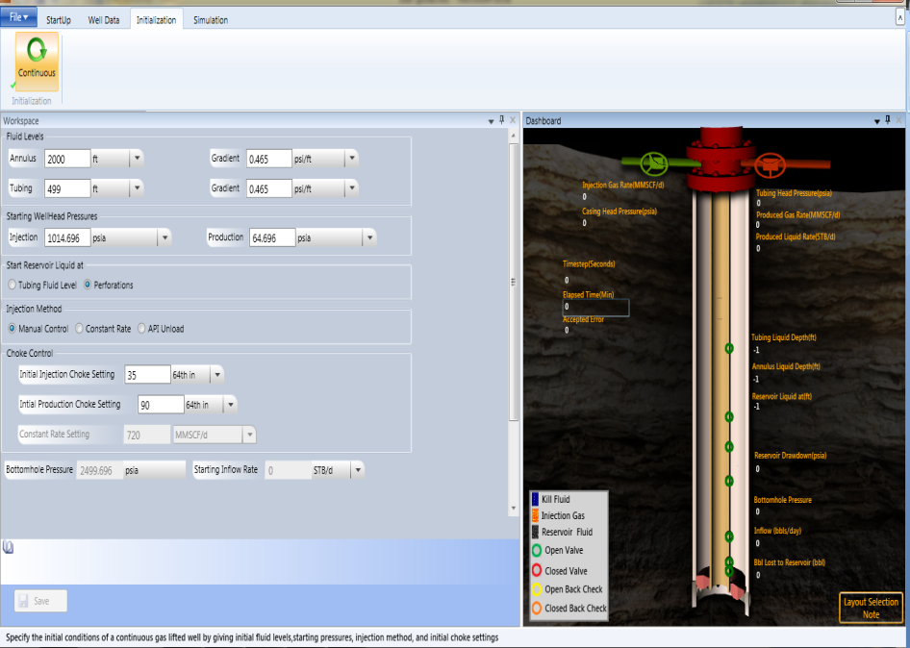

|  |  |
| --- | --- |
| C:\Documents and Settings\jv_vyasda\Desktop\!doc_tmp_folder_0\Note icon.jpg | The populated field values are not retrieved from the .WFLX file. |

1. In the **Fluid Levels** area, perform the following steps:
2. Enter true vertical depth (ft) in the **Annular** box and enter static pressure gradient (psi/ft) for the annular fluid level in the **Gradient** box.
3. Enter true vertical depth (ft) in the **Tubing** box and enter static pressure gradient (psi/ft) for the tubing fluid level in the **Gradient** box.

|  |  |
| --- | --- |
| C:\Documents and Settings\jv_vyasda\Desktop\!doc_tmp_folder_0\Note icon.jpg | Select a unit from the list of unit associated with Annular and its Gradient and Tubing and its Gradient. The initial tubing level and gradient should match the static pressure in the reservoir section. |

|  |  |
| --- | --- |
| C:\Documents and Settings\jv_vyasda\Desktop\!doc_tmp_folder_0\Note icon.jpg | Range of  Annulus level: Minimum: 0; Maximum: 100000  Tubing level: Minimum: 0; Maximum: 100000  Annulus Gradient: Minimum: 0.1; Maximum: 15000  Tubing Gradient: Minimum: 0.1; Maximum: 15000 |

1. In the **Starting Well head Pressures** area, perform the following steps:
2. Enter initial casing head pressure (downstream of the injection choke) in the **Injection** box.
3. Enter production pressure in the **Production** box.

|  |  |
| --- | --- |
| C:\Documents and Settings\jv_vyasda\Desktop\!doc_tmp_folder_0\Note icon.jpg | Select a unit from the unit list associated with Wellhead Injection and Wellhead Production. Wellhead production pressure in initialize section should not be less than separator pressure in wellhead section. |

|  |  |
| --- | --- |
| C:\Documents and Settings\jv_vyasda\Desktop\!doc_tmp_folder_0\Note icon.jpg | If unloading tubing into a pit, wellhead production pressure sets itself to ‘0’. Otherwise, for unloading to separator it should be set to a suitable initial value. It must not be less than the separator pressure defined in Wellhead Data. |

|  |  |
| --- | --- |
| C:\Documents and Settings\jv_vyasda\Desktop\!doc_tmp_folder_0\Note icon.jpg | Range of  Injection: Minimum: 14.696; Maximum: 20000  Production: Minimum: 14.696; Maximum: 20000 |

1. In the **Start Reservoir Liquid at** area, select the **Tubing Fluid Level** option or **Perforations** option (Perforation Depth).

|  |  |
| --- | --- |
| C:\Documents and Settings\jv_vyasda\Desktop\!doc_tmp_folder_0\Note icon.jpg | On selecting Tubing Fluid Level, the tubing fluid column is assumed to contain purely reservoir fluid and on selecting Perfs (perforation depth), the tubing fluid column is assumed to contain purely kill fluid. |

1. In the **Injection Method** area, select any of the following option:
2. Select the **Manual Control** option, where the gas injection rate is a function of the **Initial Inj Choke Setting** and which can be controlled during simulation by adjusting the choke setting.
3. Select the **Constant Rate** option, which can be controlled during simulation by adjusting the choke setting.
4. Select the **API Unload** option, which allows choke control as per API recommendations. This allows casing head injection pressure to increase at the rate of 50 psi/hr until 400 psig is reached and then at the rate of 100 psi/hr to system pressure.
5. In the **Choke Control** area, perform the following steps:
6. Enter a value of initial injection choke setting in the **Initial Injection Choke Setting** box. The value should be less than or equal to the maximum port size associated with the Injection Choke selected previously in **Wellhead Data**.

|  |  |
| --- | --- |
| C:\Documents and Settings\jv_vyasda\Desktop\!doc_tmp_folder_0\Note icon.jpg | Initial Injection choke settings should not be greater the maximum Injection choke settings in wellhead section. |

1. Enter a value of initial production choke setting in the **Initial Production Choke Setting** box. The value should be less than or equal to the maximum port size associated with the Production Choke selected previously in **Wellhead Data**.

|  |  |
| --- | --- |
| C:\Documents and Settings\jv_vyasda\Desktop\!doc_tmp_folder_0\Note icon.jpg | The value of Constant Rate Setting is displayed as read-only value. Also, Bottomhole Pressure and Starting Inflow Rate values are shown as read-only on the bottom. |

|  |  |
| --- | --- |
| C:\Documents and Settings\jv_vyasda\Desktop\!doc_tmp_folder_0\Note icon.jpg | Initial production choke settings should not be greater the maximum production choke settings in wellhead section. Constant rate settings text box should be enabled only if the constant rate is being selected as injection method. |

|  |  |
| --- | --- |
| C:\Documents and Settings\jv_vyasda\Desktop\!doc_tmp_folder_0\Note icon.jpg | Range of  Bottomhole Pressure: Minimum: 14.696; Maximum: 20000.  Starting Inflow Rate: Minimum: 0; Maximum: 50000. |

1. Click **Save** to save edited information.

|  |  |
| --- | --- |
| C:\Documents and Settings\jv_vyasda\Desktop\!doc_tmp_folder_0\Note icon.jpg | Invalid input data is indicated by red color box and X (cross) symbol. The Save button is also disabled on invalid input data. |
|  |  |

|  |  |
| --- | --- |
| C:\Documents and Settings\jv_vyasda\Desktop\!doc_tmp_folder_0\Note icon.jpg | User can also edit valve information from dashboard as well, for more information see [Valve Data](#valve_data_htm_figure:_edit_valv_241). |

Simulation of Dynamic Gas Lift

The simulation of DynaLift includes:

* Start, pause and terminate the simulation process.
* Specify simulation settings for *Auto-Save* and *Auto-Exit* conditions.
* Perform continuous simulation.
* Specify the parameters controlling the simulation computation such as, choke settings, control

type, and so on.

* Graphical representation of parameters by various types of graphs and on the dashboard

as well.

Start/Stop/Pause Simulation

DynaLift performs simulation using the input values specified in the ***Initialization*** screen. During the simulation, various parameters are displayed on the main screen and dashboard that are updated for each step. The produced data will depend on the selected simulation method.

To start/stop/pause simulation:

1. Select the **Simulation** tab the following screen is displayed (See [Figure](#start_stop_pause_htm_figure:_sim_3183) below).

Figure: Simulating DynaLift

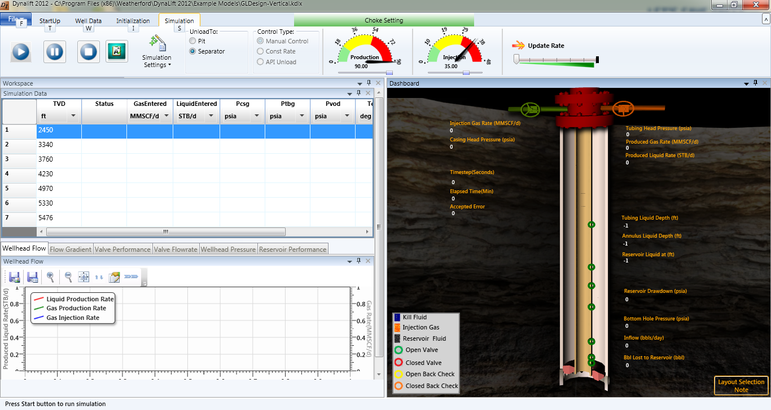

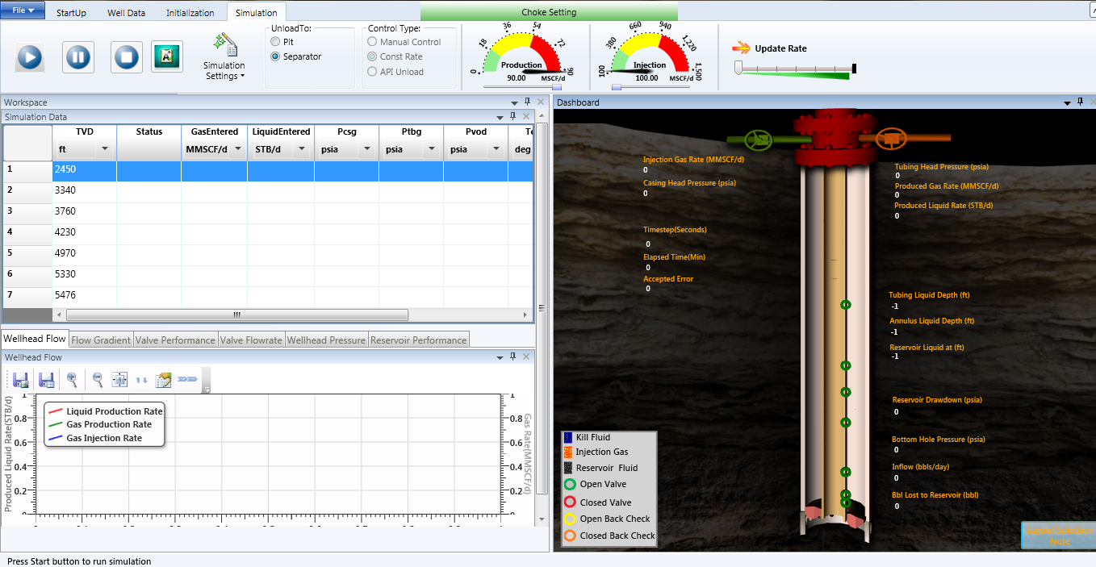

1. Click the **Start**  button to start simulation process.

  The **Start** button starts updating the table, graph, and dashboard data as simulation progresses (See [Figure](#start_stop_pause_htm_figure:_sim_1516) below).

Figure: Simulation Start

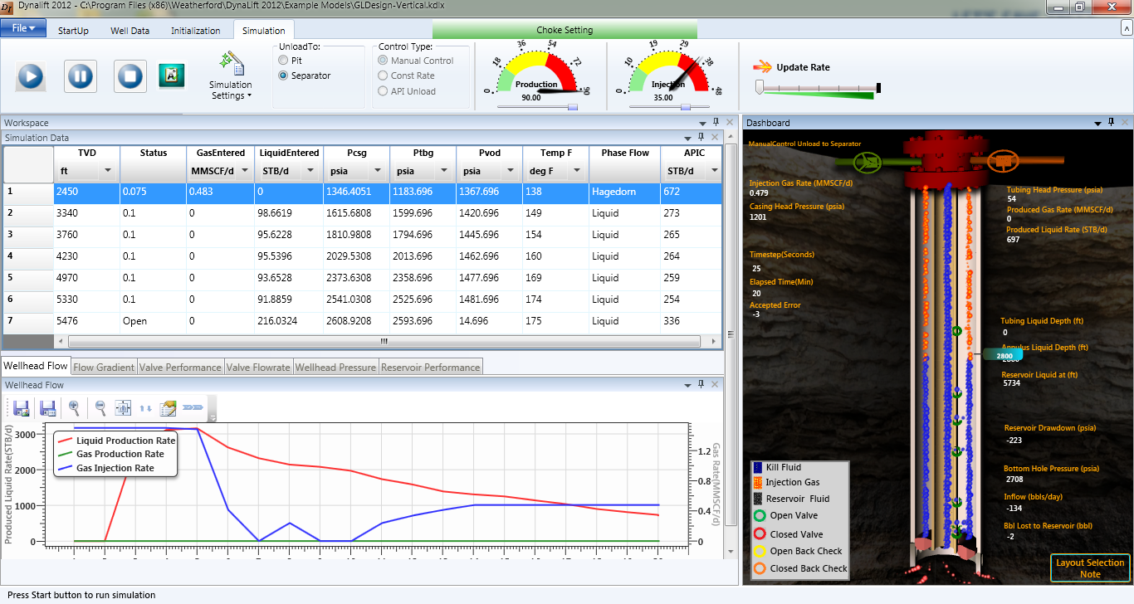

|  |  |
| --- | --- |
| C:\Documents and Settings\jv_vyasda\Desktop\!doc_tmp_folder_0\Note icon.jpg | When a user runs the simulation, in case of the incorrect configuration data be it valves or wellhead, a message box is displayed as a warning. If the discrepancy is significant, then user is forced to amend the data before going ahead with simulation else the simulation process can continue. |

1. Click the **Pause ** buttonto pause the simulation process and freeze the results at the current time step.
2. Click the **Terminate ** button to terminate the simulation.
3. Click the **Report 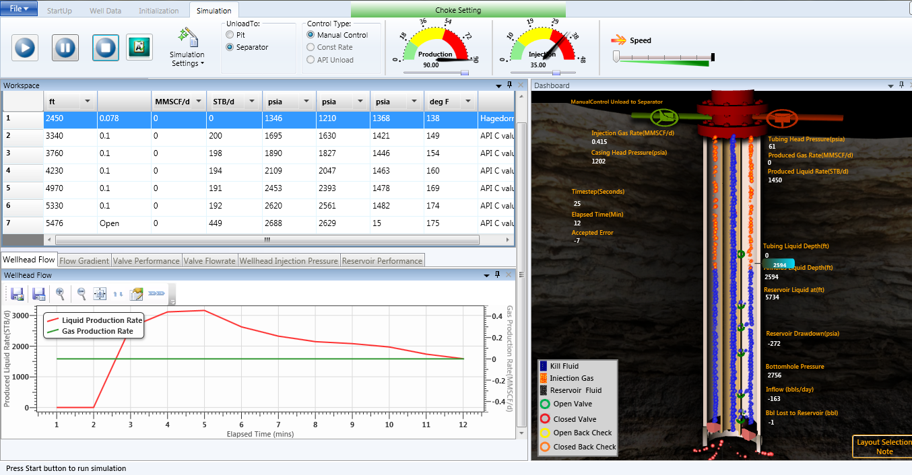** button to display the summary report of the selected model.

Dashboard

As the simulation starts, the annulus fluid (kill fluid, shown in blue) level drop, the valves open and close, and the flowing gradient slowly decrease. During the simulation, one can change the injection rate, valve port size, reservoir parameters and so on. As the well is unloaded, the user can see the production fluid in (black) flowing inside the tubing up to the surface. It is possible for the liquid to be forced back into the reservoir during the unloading process, referred as barrels lost to reservoir. This is depicted with pinkish bubbles shown flowing back to the reservoir.

Table area

The table grid area remains blank until a file is opened and you **Start** the ***Simulation*** process. During continuous simulation, the table area of the main screen holds the following information:

* **TVD**: Valve depths (ft).
* **Status**: Status of valve (open or closed). The number is the stem travel in inches. Open BC means that the valve is “back-checked” - i.e. tubing pressure > annulus pressure. Only an Orifice valve will allow flow in a reverse  
  direction.
* **GasEntered**: Injection gas flow rate through the valve.
* **LiquidEntered**: Annulus liquid flow rate through the valve.
* **Pcsg**: Pressure in the annulus at valve depth.
* **Ptbg**: Pressure in tubing at valve depth.
* **Pvod**: Test rack opening pressure corrected to temperature at depth. The valve will not open at this pressure.
* **Temp F**: Tubing fluid temperature at valve depth.
* **Comments**: During continuous simulation, “API C” values displayed in this column indicates annulus liquid being driven through the valve. According to API if this value is less than 150, then the valve will not be damaged.  
  Current practice suggests that if this value is less than 400 then the valve is safe from damage. Choked, means that the valve is passing gas in critical flow. When gas is passing through a valve in sub-critical flow, the Comments field will display either Liquid (if single-phase liquid is flowing past the valve), or the name of the flowcorrelation, e.g. Hagedorn, (if flow past the valve is multiphase).

|  |  |
| --- | --- |
| C:\Documents and Settings\jv_vyasda\Desktop\!doc_tmp_folder_0\Note icon.jpg | You can set a unit of each column data by unit list given below the each column header. The column values will display by the unit set. |

Graph Area

The graph represents the variation of liquid production rate versus elapsed time during simulation process.

Figure: Graph area

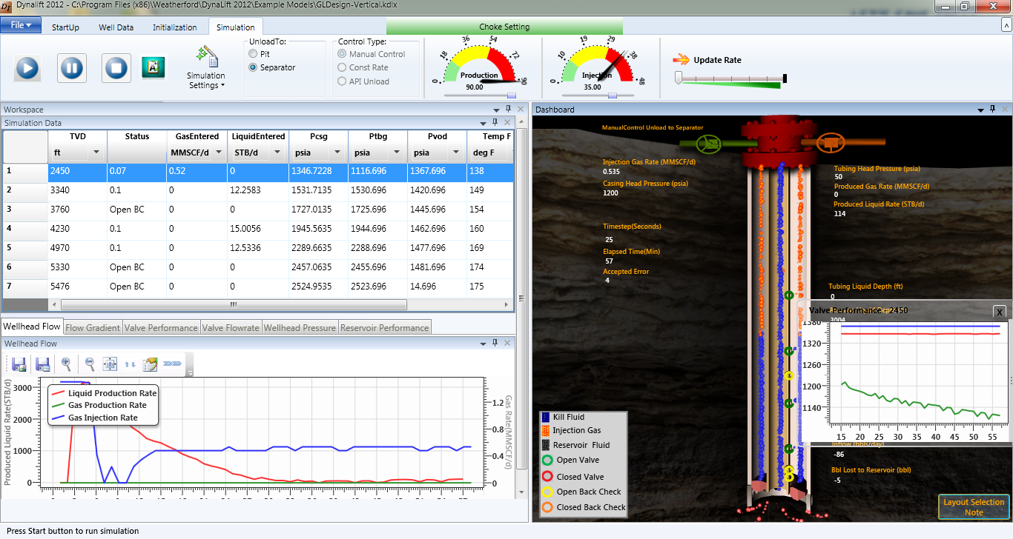

Multiple Graph View

Figure: Multiple graph view

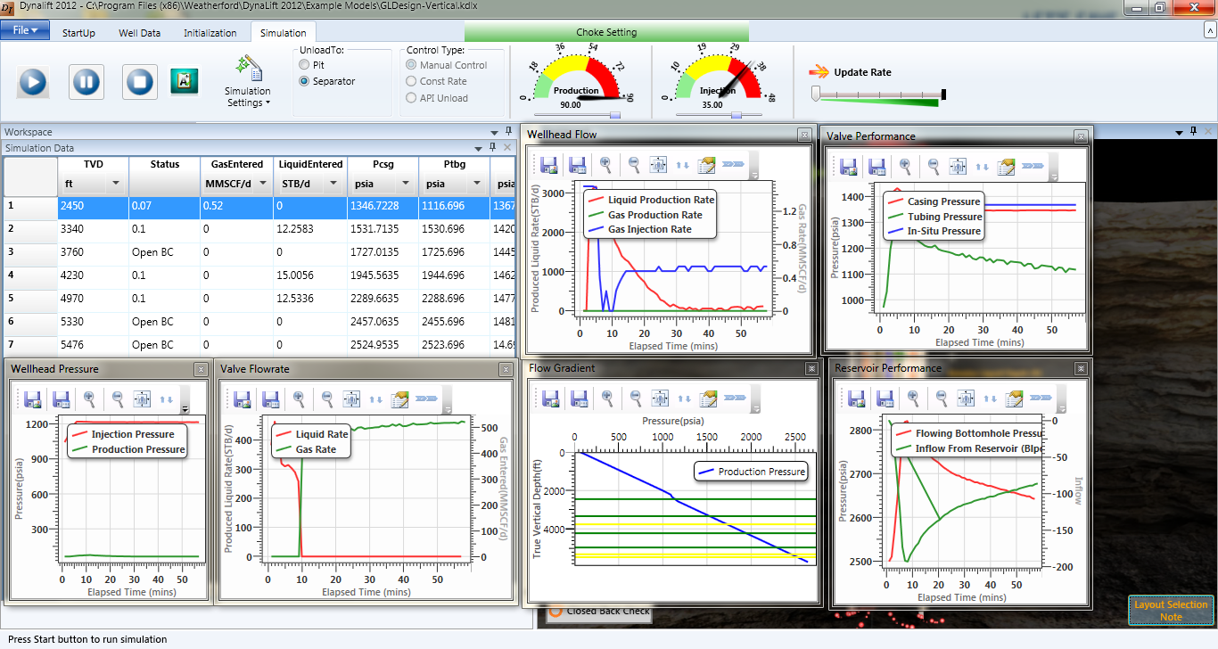

Tool Bar

Following tools are used to mange graphical data:

|  |  |  |
| --- | --- | --- |
| **S.No.** | **Tool** | **Description** |
| 1. | C:\Documents and Settings\jv_vyasda\Desktop\!doc_tmp_folder_0\icon_SaveAsImage.JPG | Saves graph generated as image (.BMP.PNG,.TIFF,.JPG,.GIF). |
| 2. | C:\Documents and Settings\jv_vyasda\Desktop\!doc_tmp_folder_0\icon_SaveToFile.JPG | Saves graph generated into a file (.XML,.XLS,.CSV). |
| 3. | C:\Documents and Settings\jv_vyasda\Desktop\!doc_tmp_folder_0\icon_ZoomIn.JPG | Enlarges the graph generated. |
| 4. | C:\Documents and Settings\jv_vyasda\Desktop\!doc_tmp_folder_0\icon_ZoomOut.JPG | Zoom out the graph generated. |
| 5. | C:\Documents and Settings\jv_vyasda\Desktop\!doc_tmp_folder_0\icon_FitToScreen.JPG | Fits the graph generated into screen available. |
| 6. | C:\Documents and Settings\jv_vyasda\Desktop\!doc_tmp_folder_0\icon_EditChart.JPG | Edit properties of the chart generated. |

|  |
| --- |
|  |

Simulation Settings

The Simulation Setting is used to set auto save, auto exit, and the settings for the continuous simulation as shown in figure below:

Figure: Simulation Setting Group

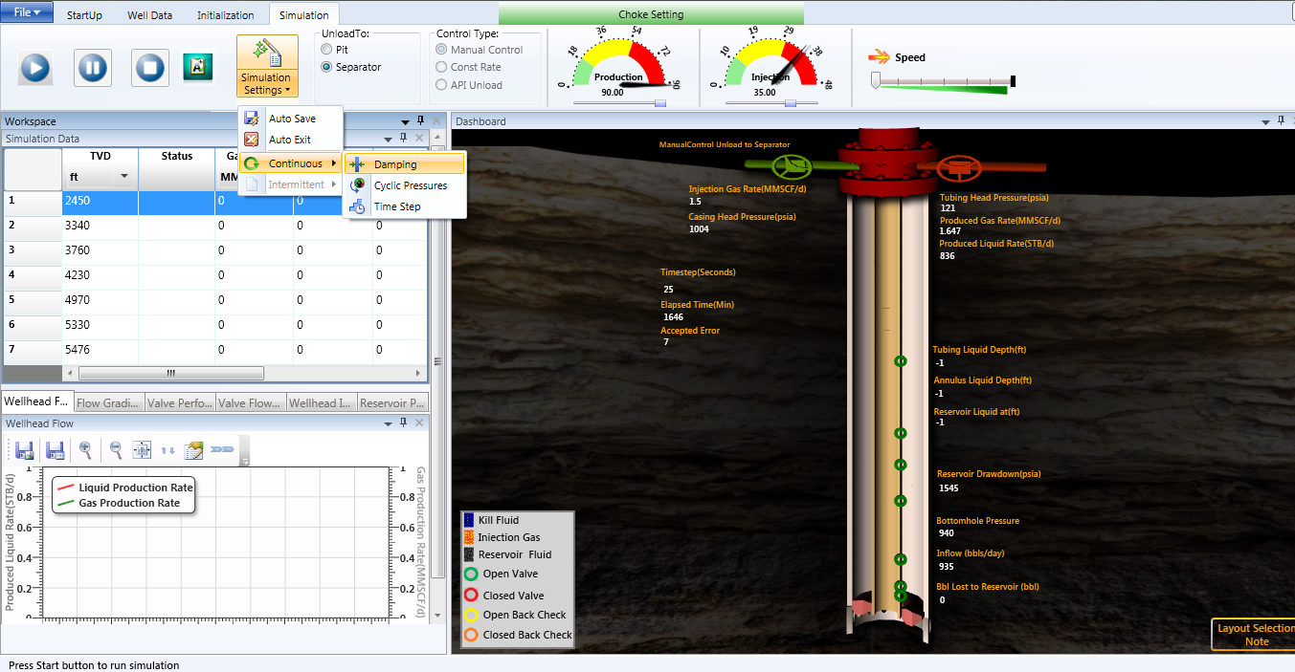

Auto Save

The **Auto Save** option is used to define automatic save durations for several data groups. This can be done before starting the simulation, or during the calculations.

To perform auto save:

1. Select **Simulation** tab **> Simulation Settings** group **>** point to **Auto Save**, the following screen is displayed (See [Figure](#general_setting_auto_save__auto__3632) below) where you can select required checkbox (es).

Figure: Auto-Save Simulation Data dialog

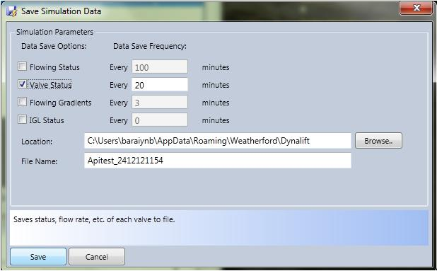

* If you enter the **Auto Save** option during the simulation run, the calculations will be frozen until you **Save** or **Cancel** from the dialog.

1. These files are comma-delimited and are best read in a spreadsheet program such as Microsoft Excel. To read in the headers correctly, set the Text Qualifier in the Excel Text Import Wizard (Step 2) to “None”. In the **Data Save options**, the following auto save process status is displayed.
   * Flowing Status: Saves the Wellhead Data to a file with the extension .FLW.
   * Valve Status: Saves the Flowrate, Status, etc., of each Valve to a file with the extension .VLV.
   * Flowing gradients: Saves Tubing Flowing Pressures, Gradients and Depth Parameters to a file with the extension .GRD.
   * IGL Status: Saves IGL data to a file.

Figure: Help tip for Valve Status



1. Under **Data Save Frequency**, enter **Every *n* Minutes**, which allows you to define the elapsed time between saves.

Auto Exit

The **Auto Exit** option allows you to define parameters for DynaLift to *Autostop* and *Exit* a Simulation. Please note that apart from the option to **Stop at elapsed time of**, none of the other options applies to intermittent Gas Lift. You may edit these settings before or during a simulation run.

To perform auto exit:

1. Select **Simulation** tab**> Simulation Settings** group**>** point to **Auto Exit**, the following screen is displayed (See [Figure](#general_setting_auto_save__auto__3632) below).

Figure: Auto Stop and Exit dialog

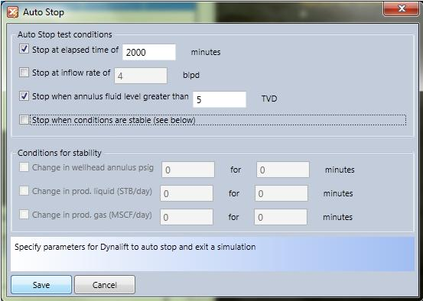

1. Select the following auto exit test conditions given.

* Stop the simulation when elapsed time reaches the user provided value.
* Stop the simulation when inflow rate reaches the user provided value.
* Stop the simulation when annulus level becomes greater than the user provided value.
* Stop the simulation when one of the following stable conditions is reached.

Figure: Stability Conditions:

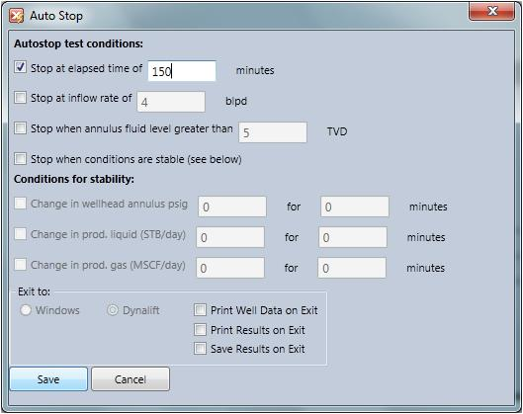

* + Change in wellhead annulus pressure is less than X psig for Y minutes.
  + Change in produced liquid rate is less than X psig for Y minutes.
  + Change in produced gas rate is less than X psig for Y minutes.

1. Click **Save** to save the data entered and **Cancel** to exit from the dialog box.

|  |  |
| --- | --- |
| C:\Documents and Settings\jv_vyasda\Desktop\!doc_tmp_folder_0\Note icon.jpg | When the Auto Exit occurs the current parameter values will be added to the  appropriate files if any have been selected under Auto Save. |

Continuous Simulation

The **Continuous** option is used to perform continuous simulation process by damping and cyclic pressure option as shown in the following figure:

Figure: Continuous Simulation

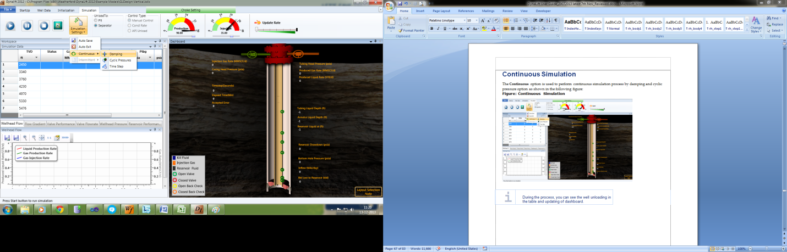

|  |  |
| --- | --- |
| C:\Documents and Settings\jv_vyasda\Desktop\!doc_tmp_folder_0\Note icon.jpg | During the process, you can see the well unloading in the table and updating of dashboard. |

Damping

The **Damping** option is used to perform continuous simulation process by damping factor method. This damps the effect of sudden changes in the calculated variables from one time step to another.

To perform continuous damping simulation:

1. Select **Simulation** tab **> Simulation Settings** group **>** point to **Continuous >** click **Damping**, the following screen is displayed (See [Figure](#continuous_simulation_htm_figure_9798) below).

Figure: Continuous Simulation: Damping

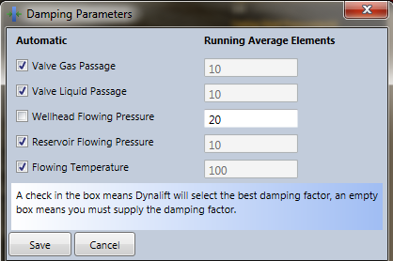

1. In the **Damping** screen, perform the following steps:
2. Under **Automatic**, select the following checkboxes to set the damping factor by DynaLift itself:
   * Valve gas passage
   * Valve liquid passage
   * Wellhead flowing pressure
   * Reservoir flowing pressure
   * Flowing temperature
3. Damping can be set as *Automatic*, or *Manual* by deselecting the above checkboxes and entering number of elements to use for the running average by user in the above corresponding checkboxes under **Running Average Elements**.
4. Click **Save** to accept entered data or **Cancel** to reject the data.

Cyclic Pressure

The **Cyclic Pressure** option is used to perform continuous simulation process by cyclic pressure method. This allows you to account for cyclical field or test condition variations, such as heading.

To perform continuous cyclic pressure simulation:

1. Select **Simulation** tab **> Simulation Settings** group **>** point to **Continuous >** click **Cyclic Pressure**, the following screen is displayed (See [Figure](#continuous_simulation_htm_figure_461) below).

Figure: Continuous Simulation: Cyclic Pressures

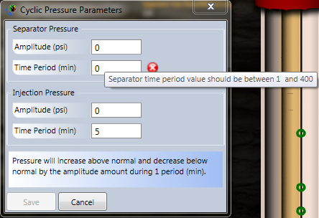

1. **In** the **Cyclic Pressure** screen, perform the following steps:
2. Under **Separator Pressure**, enter possible cyclic variation value in the **Amplitude** box and **Time Period** box.
3. Under Injection **Pressure**, enter cyclic variation peak-to-peak value in the **Amplitude** box and **Time Period** box.

|  |  |
| --- | --- |
| C:\Documents and Settings\jv_vyasda\Desktop\!doc_tmp_folder_0\Note icon.jpg | Select a unit from the list of unit associated with Amplitude and Time Period. |

1. **Click** **Save** to accept entered data or **Cancel** to reject the data.

Time Step

To set time step:

1. On the **Simulation** tab**> Simulation Settings** group**>** point to **Continuous >**click **Time Step**, seconds, and then select the **Automatic** option, that allows user to enter the minimum and maximum values in the **Min** and **Max** boxes respectively.

Figure: Time step Parameters

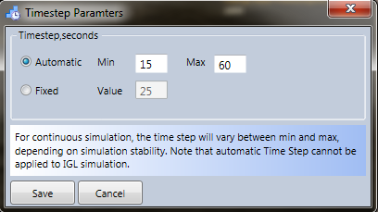

1. Select the **Fixed** option that allows user to enter a fixed time step value in the **Value** box.

|  |  |
| --- | --- |
| C:\Documents and Settings\jv_vyasda\Desktop\!doc_tmp_folder_0\Note icon.jpg | Below the gauge control, the actual well schematic is present. |

* The results shown on the well schematic are injection pressure and gas rate on injection choke side, production pressure and liquid & gas rate shown on the production choke side.
* This defines the size of the time step allowed for the Simulation.

Figure: Fixed Time Step dialog

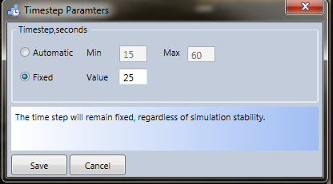

1. Click **Save** to accept entered data or **Cancel** to reject the data.

* For continuous simulation, time-stepping can be **Automatic** between a *Minimum* and *Maximum* length (in sec.), or **Fixed** to a certain specified value (in seconds).
* During continuous lift, automatic time-stepping will vary between the minimum and the maximum settings depending on the simulation stability.
* A *Minimum* of 5 - 15 seconds and a *Maximum* of 30 - 50 seconds is usually adequate. The use of a fixed step size is not recommended during the unloading process, as it is highly unstable in nature.

Gauge Control, Unload, Control Type, and Speed Control

In the **Simulation** tab, besides the **Simulation Settings**, there are *Unload To*, *Gauge Control, Control Type, and Speed Controller* optionsto change the choke settings and injection method during simulation process.

Unload to Separator / Pit

To unload simulation:

* On the **Simulation** tab > **Unload To** group, select any one option, ***Separator*** option or ***Pit*** option.
  + Unload to pit: This option allows produced fluid unloading to pit (atmospheric pressure).
  + Unload to separator: This option allows the unloading of tubing fluid to separator (see [Figure](#simulation_unload_timestep_htm_f_2236) below).

|  |  |
| --- | --- |
| C:\Documents and Settings\jv_vyasda\Desktop\!doc_tmp_folder_0\Note icon.jpg | The Unload To options can be used during simulation. |

Figure: Unload to Separator / Pit

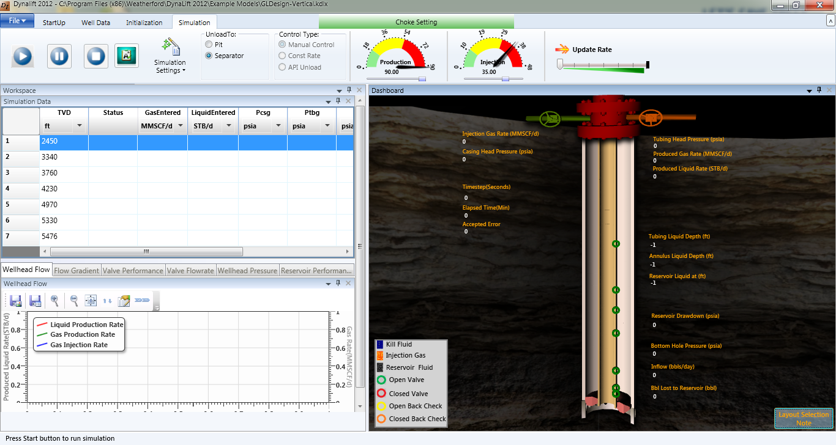

Gauge Control

The gauge control is used to show the choke settings graphically in the form of gauges (see [Figure](#simulation_unload_timestep_htm_f_2480) below).

Figure: Gauge Control for choke setting

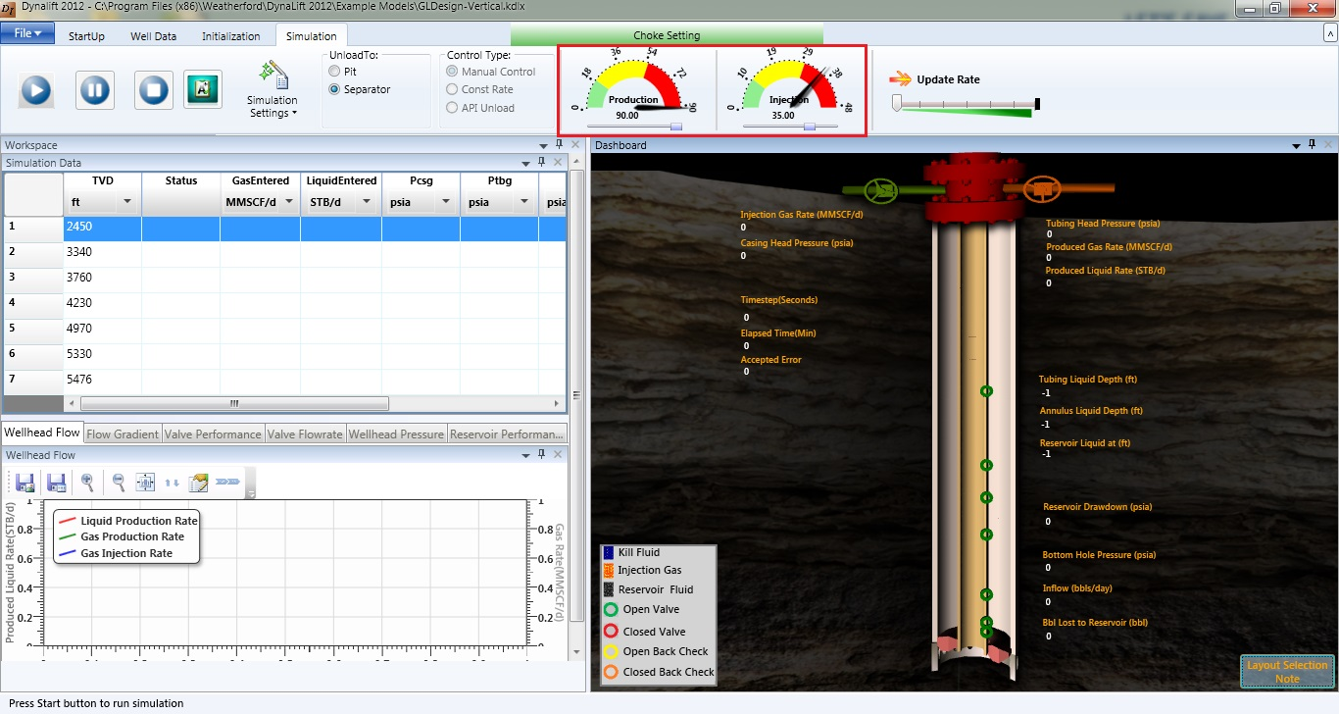

Control Type

You can select any one from the following three control types (see [Figure](#simulation_unload_timestep_htm_f_1440) below):

To specify control type:

* On the Simulation tab > Control Type group, select any one option, Manual Control or Constant Rate or API Unload option.
  + Manual Control: The gas injection rate is a function of the Max Choke Setting and the Available Injection Pressure fields specified in the Wellhead Data screen. The gas injection rate can be controlled during simulation by adjusting the choke setting, or even changing the control types.
  + Constant Rate: The gas injection rate is set to the specified constant value for simulation process.
  + API Unload: This allows casing head injection pressure to increase at the rate of 50 psi/hr upto 400 psig and then at the rate of 100 psi/hr to system pressure.

Figure: Control Type

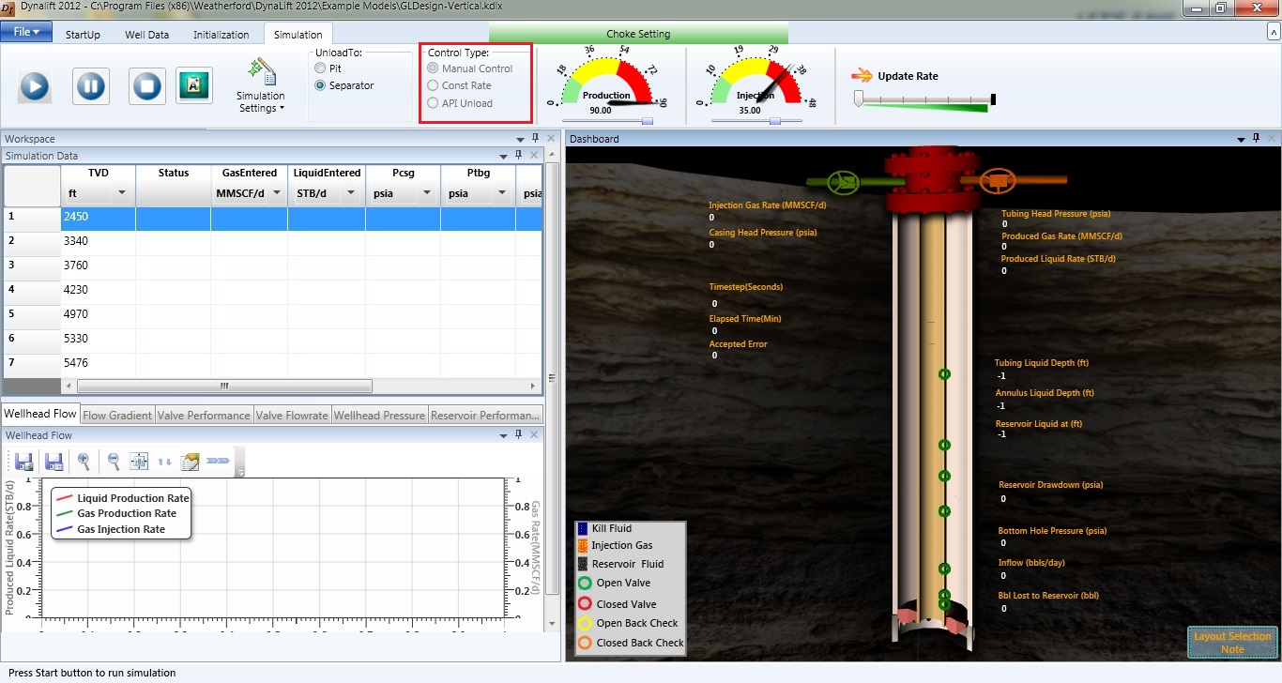

Speed Controller

The speed controller slider can be used to increase or decrease the speed of simulation; the speed in this context indicates the UI screen update turnaround. That is increasing the step value in the slider, skips the result steps to be updated on the screen thereby by the user expedites the on-screen well unload action during the simulation process.

Figure: Speed Controller

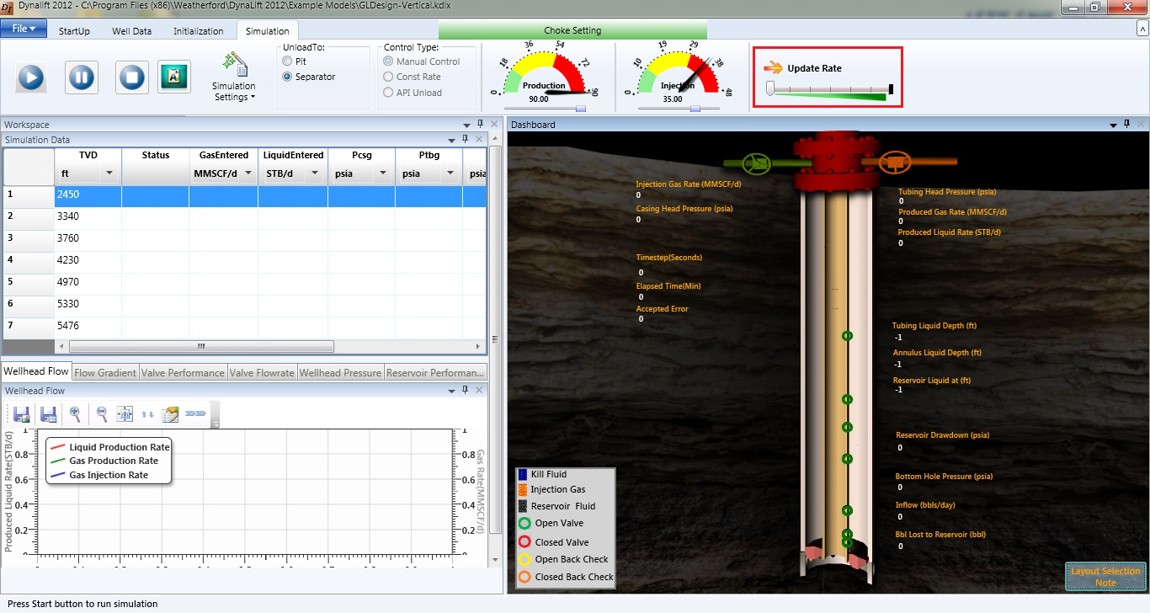

|  |  |
| --- | --- |
| C:\Documents and Settings\jv_vyasda\Desktop\!doc_tmp_folder_0\Note icon.jpg | The speed controller does not visually increase the rate on dashboard in which the simulation appears. |

Graphs

At the bottom of the input dialog area, graphical representation is displayed for Continuous simulation method. The graphs can also be viewed by clicking well wall on the dashboard.

The simulation graphs present the following results calculated during simulation:

* [Wellhead Flow](#graphs1_htm_wellhead_flow_rate)
* [Flow Gradient](#graphs1_htm_flowing_gradient_)
* [Valve Performance](#graphs1_htm_valve_performance)
* [Valve Flow Rate](#graphs1_htm_valve_flow_rate)
* [Wellhead Injection Pressure](#graphs1_htm_wellhead_injection_p_683)
* [Reservoir Performance](#graphs1_htm_reservoir_performanc_9546)

Wellhead Flow

This plot displays the *Liquid-Gas Production Rates and Gas Injection Rate* (at standard conditions) with time.

Figure: Produced Fluids plot showing liquid and gas production rates and Gas Injection Rate

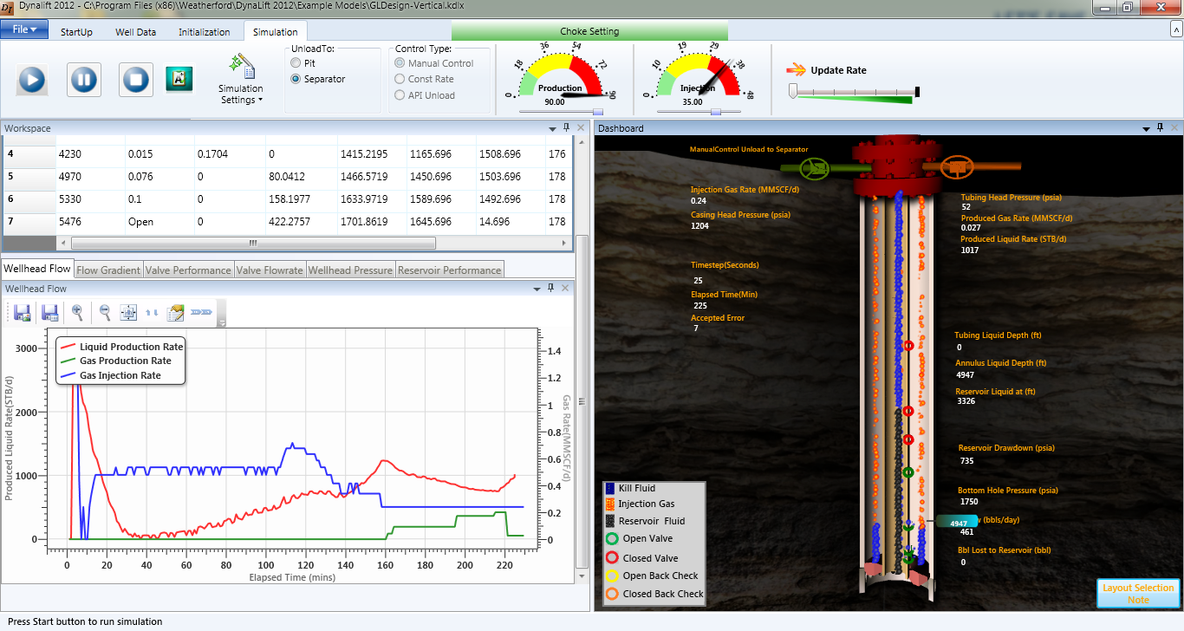Flow Gradient

Figure: Flow Gradient plot during early part of the unloading sequence

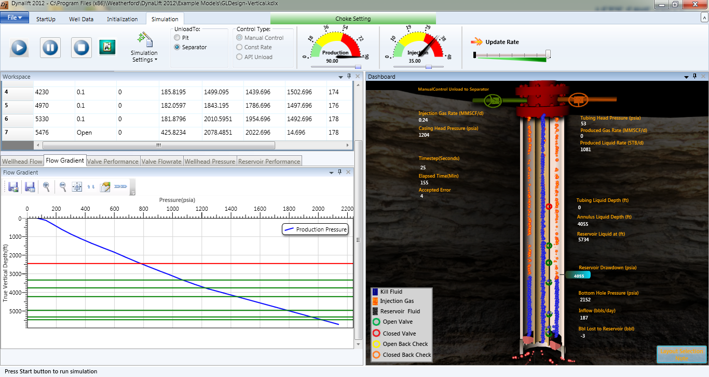

* This graph is flow gradient plot that will have Tubing pressure plotted against depth.
* The point on the X-axis where tubing pressure curve ‘WHP’ (Wellhead pressure.
* The valve depth shows with solid lines.
* The initial graph also has SBHP (Static bottomhole pressure) at the end of tubing pressure line.
* As soon as the gradient changes the graph shifts to the left and we have FBHP (flowing bottomhole pressure) as the end of tubing pressure line.

Valve Performance

The screen displays the Piod (casing), Ptf (tubing) and Pvo (in-situ setting pressure) versus Time for each of the valves. Select the Valve Depth from the **Valve Selection** box on the left-hand side and the simulated results will be displayed. This graph can also be viewed by clicking the valve on the dashboard, see [Figure](#Simu_Val) below.

Figure: Valve Performance

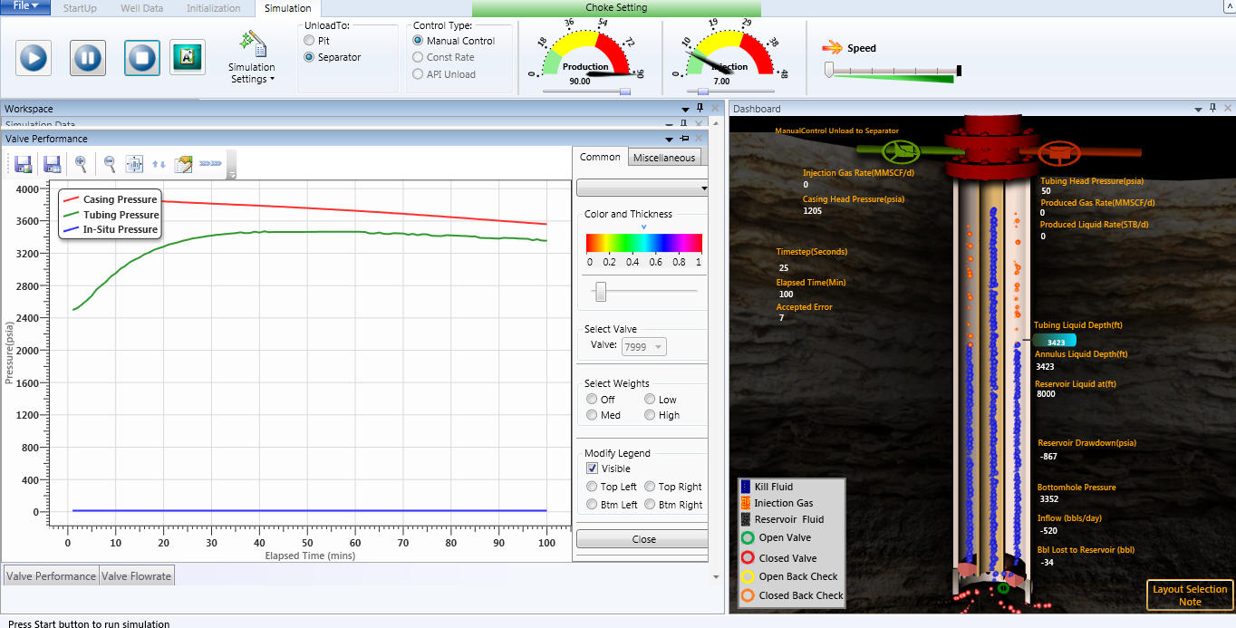

Figure: Valve Performance Graph- Viewed by clicking on the dashboard

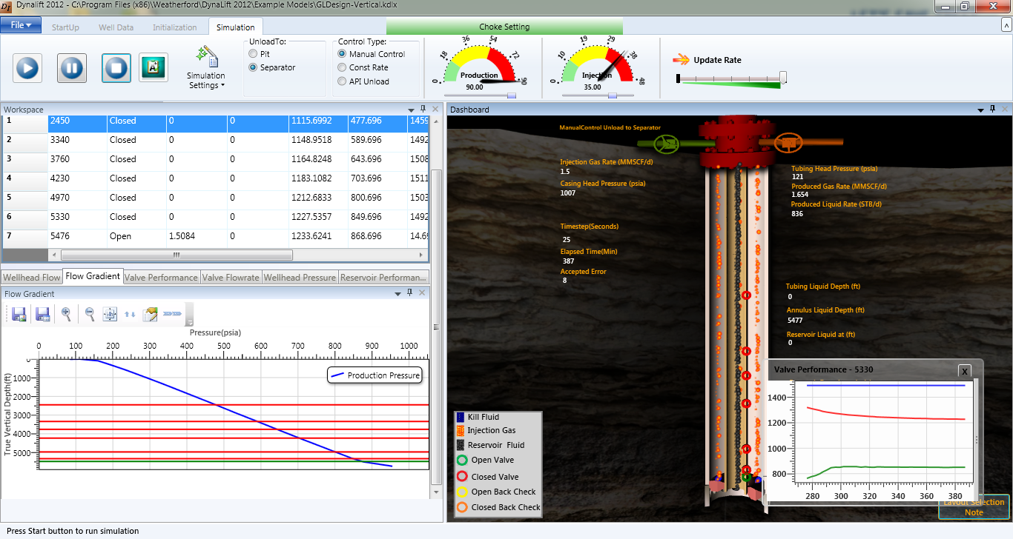

Valve Flow Rate

The screen displays the flow rate of Liquid and Gas through the Valve versus Time for each of the valves. Select the Valve Depth from the **Valve Selection** box on the left-hand side and the simulated results will be displayed.

Figure: Valve Flow Rate

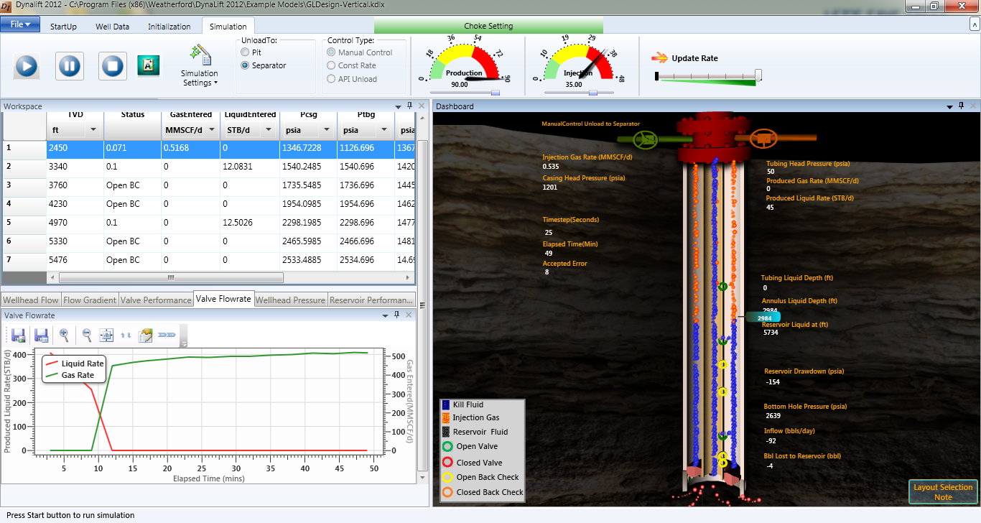

Wellhead Pressure

This plot displays Injection and Production Pressures versus Time.

Figure: Wellhead Pressure

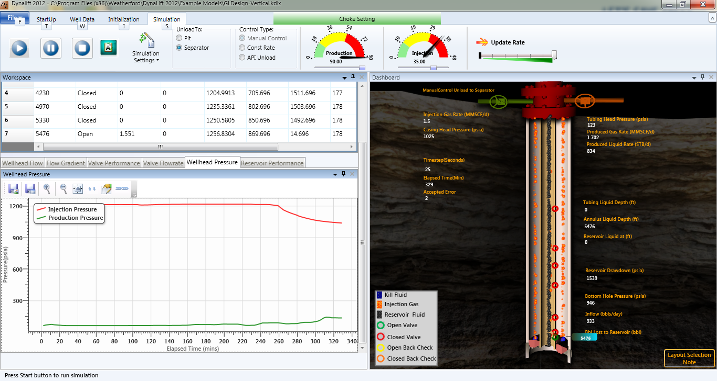

Reservoir Performance

This plot displays the *Flowing Bottomhole Pressure* and the *Inflow (reservoir bbls/day of liquid)* from the Reservoir.

* Negative number indicates that the fluid flow is into the Reservoir.

Figure: Reservoir inflow and bottom hole flowing pressure (Pfbh)

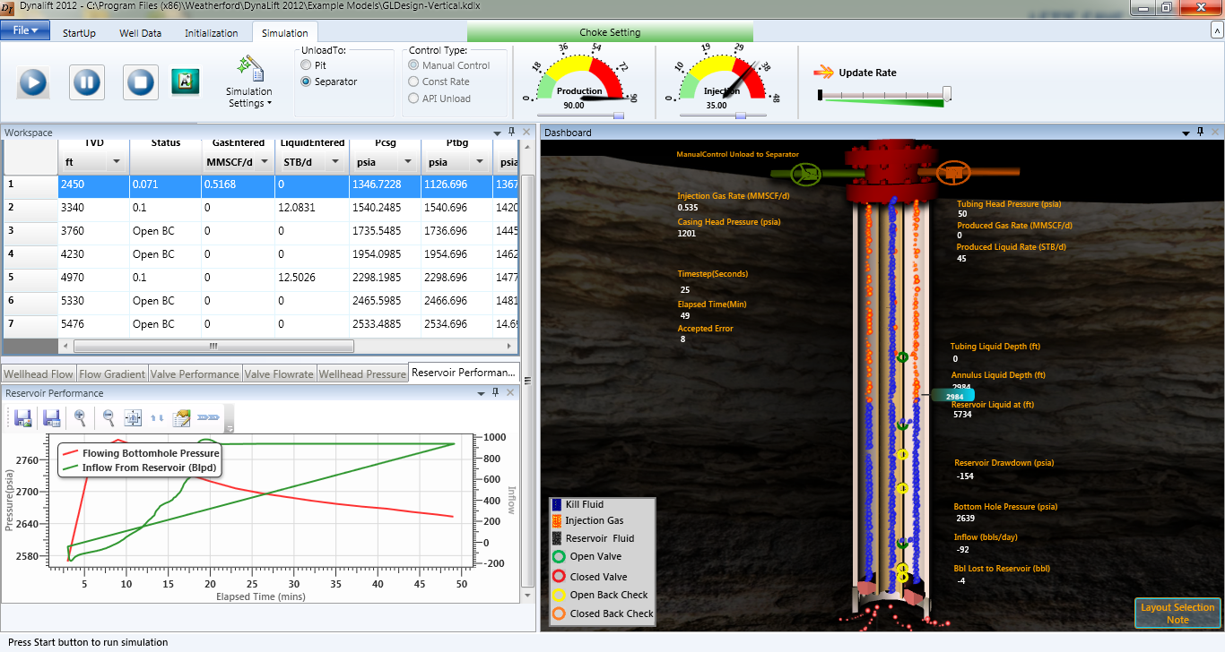

Toolbar

The following tools are used to save, view, and edit the graphical data:

|  |  |  |  |  |  |  |  |  |  |  |  |  |  |  |  |  |  |  |  |  |  |
| --- | --- | --- | --- | --- | --- | --- | --- | --- | --- | --- | --- | --- | --- | --- | --- | --- | --- | --- | --- | --- | --- |
| |  |  |  | | --- | --- | --- | | **S.No.** | **Tool** | **Description** | | 1. | C:\Documents and Settings\jv_vyasda\Desktop\!doc_tmp_folder_0\icon_SaveAsImage.JPG | Saves graph generated as image (.BMP, .PNG, .TIFF, .JPG, and .GIF). | | 2. | C:\Documents and Settings\jv_vyasda\Desktop\!doc_tmp_folder_0\icon_SaveToFile.JPG | Saves graph generated into a file (.XML, .XLS, and .CSV). | | 3. | C:\Documents and Settings\jv_vyasda\Desktop\!doc_tmp_folder_0\icon_ZoomIn.JPG | Enlarges the graph generated. | | 4. | C:\Documents and Settings\jv_vyasda\Desktop\!doc_tmp_folder_0\icon_ZoomOut.JPG | Zooms out the graph generated. | | 5. | C:\Documents and Settings\jv_vyasda\Desktop\!doc_tmp_folder_0\icon_FitToScreen.JPG | Fits the graph generated into screen available. | | 6. | C:\Documents and Settings\jv_vyasda\Desktop\!doc_tmp_folder_0\icon_EditChart.JPG | Edits the properties of the chart generated. | |

Display Summary

Summary Report

The **Report** button is used to generate a summary report of the model after running the simulation to present the final results and complete charts.

To display summary report

* Click the Report button  to display the summary report of the selected model.

Figure: Summary Report

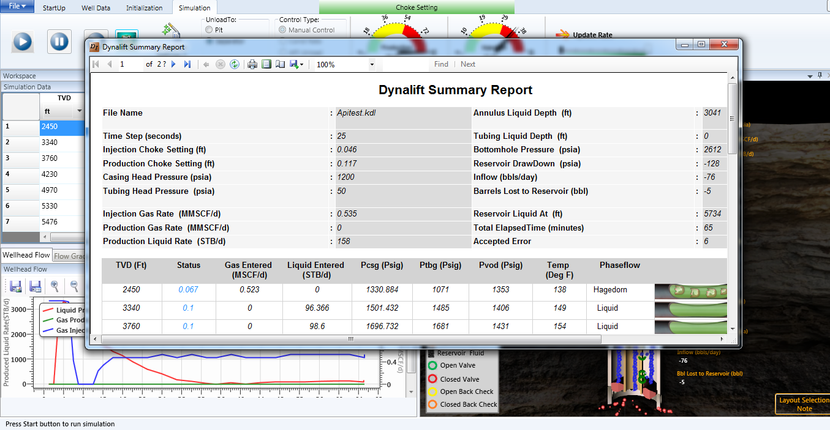

The ***Summary Report*** contains the final results and complete charts including file name, well configuration information, Initialization, Simulation parameters of the selected model.

Known Issues

The following are the known issues in this version of DynaLiftTM version 4.0.1:

* On the *Well Identification* screen, the ***Date*** being populated for models files is not saved.
* When using *Unload Destination* as *Pit*, application hangs. The issue has been noticed in DynaLift version 3.6 too.
* Unit conversion for *Formation Volume Factor* and *Geo Thermal gradient* does not work. This is an issue with epLibrary.
* In Windows 7, the user should have administrator privileges to run and view the simulation.

WellFlo Setup

* Install latest WellFlo setup on test machine.
* Copy Dictionary.ENU.xml from the Language folder to C:\Documents and Settings\<<username>>\Local Settings\Application Data\Weatherford\Dynalift\ on the test PC.

Features Supported:

* Loading existing model (DynaLift (.kdl;.kdlx) and WellFlo (.wflx)
* Modification and Saving model
* Creation of new Model
* Calculation of PVT Results
* Continuous Simulation
* Animation
* License – Proper DynaLift and Valve licenses are required to run the application.

Features not Supported

* Intermittent Simulation
* About tool button
* Localization

Index

\*

.KDLX 29

A

Action buttons 24

Auto Exit 70

Auto Save 69

B

Bend area 44

Bubble Point : (psia) 50

Buttons 23

C

CasingID 38

Choke Control 61

Completion Data 38

Configure Well Information 31

Continuous Initialization 59

Continuous Simulation 73

Cyclic Pressure 74

D

Damping 73

Timestep 75

Control Type 78

Create New Well Model 32

Damping 73

Dashboard 24

Dashboard on simulation 65

Deep Well Flow Correlation 37

Deviation 40

Devices 39

Dome Volume 56

DynaLift installation 9

DynaLift Interface 20

DynaLift StartUp screen 17

DynaLift Workflow 15

DynaLift Workflow Diagram 16

E

Edit valve 57

Exit form DynaLift 19

F

Fixed Time 76

Flow Correlation 36

FlowLine area 45

Fluid Gravities area 48

Fluid Levels area 51

Fluid Volume 56

G

Gas Composition, mole % area 49

GasEntered 66

Gauge Control 78

Graph Area 66

Graphs 80

Flow Gradient 81

Reservoir Performance 84

Toolbar 85

Valve Flow Rate 82

Valve Performance 81

Wellhead Flow 80

Wellhead Injection Pressure 84

H

Help tip 70

Help tip area 24

I

Initializing DynaLift 59

Injection data area 46

Injection Method ar 60

Inner Diameter 44

Input dialogs 23

Insert Row Above The Selected Row 41

Insert Row to Table 40

K

Known Issues 87

L

Length 46

Load DynaLift Application 17

Load Rate 56

M

MD 39

Multiple graph 68

N

Next 51

Normalize 51

P

Pause 65

Pcsg 66

Perfs 40

Previous 51

Prod Index 55

Ptbg 66

Ptro (Test Rack Opening Pressure 56

Pvod 66

PVT Data 48

R

Remove Row 42

Reservoir Conditions area 52

Reservoir Data 52

Reservoir Free Gas : (MSCF/day) 50

Results 50

Roughness 39, 44

S

Save 51

Selecting Units 29

Separator area 45

Show Dashboard 21

simulation of Dyn 63

Solution GOR : (SCF/STB) 50

Speed Controller 79

Stability Conditions 71

Start 64

Start/Stop/Pause Simulation 64

Starting Well head Pressures area 60

Summary Report 86

TTemp F 66

Terminate 65

Tool Bar 68

TubingID 38

TubingOD 38

Tuning factor “L” 36

TVD 39

U

Unit Editor 29

Unload to Separator 77

V

Valve Data 56

Valve Depth 56

Valve Type 56

*Vertical Flow Correlation* 36

Vogel AOF 55

W

Water Cut (fraction) 55

Well and Flow Type 49

Well Head Data 43

Well Identification Data 35

Well Test Data 53